ECOSOC Topic 1: Improvement of Megacities' Urban Structure in order to Obtain Stable Economic and Social Conditions.

The United Nations Economic and Social Council is one of the six principal organs of the United Nations, responsible for rising the general standard of living in the world by establishing solution proposals for international economic and financial problems .

Key Therms

Megacities
A megacity is a very large city, typically with a total population in excess of 10 million people. Often a large part of the national gross domestic product is produced in megacities.

Urban Structure
Map of all megacities today marked by red points
Urban structure is the arrangement of land use in urban areas, in other words: how the land use of a city is set out. Urban planners, economists, and geographers have developed several models that explain where different types of people and businesses tend to exist within the urban setting.

Stable Economy
Economic stability is the absence of excessive fluctuations in the macroeconomy. An economy with fairly constant output growth and low and stable inflation would be considered economically stable.

Macroeconomics
Macroeconomics is the developing of models that explain the relationship between such factors as national income, output, consumption, unemployment, inflation, savings, investment, international trade and international finance.

Shanty-Town (Slum)
A Shanty-Town is an area in or near a city in which poor people live in small, badly built houses mostly illegally and in bad living conditions.

Gated Communities
In its modern form, a gated community is a form of residential community or housing estate containing strictly controlled entrances for pedestrians, bicycles, and automobiles, and often characterized by a closed perimeter of walls and fences. Only authorized persons can enter these areas. In general, people with higher income live in those districts.
Example picture of a shanty-town in Rio de Janeiro,Brazil

Gross Domestic Product
The GDP is the total value of goods produced and services provided in a country during one year.
Informal Sector
The informal sector, informal economy, shadow economy or grey economy is the part of an economy that is neither taxed, nor monitored by any form of government.

The graph shows the percentage of the informal sector of the economy in every country
Decentralization
Decentralization is the movement of departments of a large organization away from a single administrative centre to other locations.

Issue Explanation

In 2016, an estimated 54.5 per cent of the world’s population lived in urban settlements. Not only are more cities founded, the existing cities are also getting larger but that does not always make them better. Megacities such as Kolkata, Mumbai, Manila, Sao Paolo, Lagos and Mexico City present a great opportunity for large corporate companies.They also provide thrilling features for journalists and a rich trove for academic researchers. Even though megacities bring much advantages with them, they are also a tragic replay of the worst aspects of mass urbanization. Through the immense size of the cities the infrastructure is weakened and it is more complicated to reach several parts of the city easily. This can often be seen in the poorer parts of the town which are likely to evolve into shanty-towns, partly caused by the missing connection to the rest of the town. As a consequence, most of the people who live in megacities have to suffer from the size of the town. Furthermore, these problems are increased by the natural reaction of people who live in better conditions because they found gated communities, but that causes even more complicated connections between different parts of the city.
Besides, the most problematic and challenging problems in megacities are related to infrastructure: water supply, sewage disposal, environmental problems, unemployment, high crime rate, and lack of living space.
In order to increase the standard of living and the economy in a way that every inhabitant in the city can benefit from it, it is the mission of this committee to find solutions to fight these problems.
To ensure a good standard of living in the first place it is necessary to take first steps toward a stable infrastructure, which can be reached by setting up an electric network or street system in shanty towns or poorer city parts in order to integrate them more into the city, or by creating a water pipe network - to only name a few measures. It is also very effective to fight the informal sector because, then, it can be possible to regulate work and living conditions better. The taxes which are regained from the informal sector can be used to develop the urban structure even more. To fight the informal sector, data could be collected in order to prevent informal economy actions, or informal work could be tackled strictly.
To develop a city in general it is important to establish education facilities because educated inhabitants have more chances to increase their standard of living and to get a well-paid job, which strengthens the economy and makes the informal sector less attractive. Moreover, it is important to build social and public facilities, such as hospitals to rise the medical supply, police stations to fight crime, fire departments, orphanages, or public transportation systems and green areas such as parks to increase the air quality and give the inhabitants places to meet or spend their leisure time.
All these are only some examples how it could be possible to set up a new structure decentralizing the city in order to make it possible that a stable economy can develop and provide a good standard of living and economic continuity for all urban districts. So the aim is to create cities which can handle the immense number of over 10 million inhabitants because of their well-planned urban structure.

Background Information
Throughout history, cities have attracted people as centers of culture, religion, learning, and economics. Looking back, the first wave of urban migration took place in what are today’s more developed countries, especially in Europe and North America. This was possible because of the technical developments. Today the technological development breaks every barrier of distance by transportation and digital technologies, so nothing is preventing people from moving from the countryside into cities. So if we are looking ahead, 90 percent of the future urban increase is expected to take place in Asia and Africa, and it is projected that close to two-thirds of all people will be calling cities their home by 2050.
Urbanization is often linked with economics. Increased job opportunities, a centralized market, better pay and higher individual wealth have all drawn people into cities. And these pull factors are what causes cities to grow. The Industrial Revolution caused a shift from agriculturally based societies to industrial, and thus geographically centered, societies.
The urban shift over time has led to the emergence of the megacity. New York City and Tokyo were the first known megacities, both reaching an urban conglomeration of over 10 million by the 1950s. But today they are far from being specific in size. In 2014 there were 28 megacities across the planet. Most of the cities that have reached the 10 million marker in recent years are located in Asia and Africa. In fact, this is where seven of the eight latest megacities can be found.
A big number of these huge megalopolises are often unable to manage the challenges that their vast and growing urban populations pose. If no are taken soon, the megacities will deteriorate into lawless criminal areas with inhuman living conditions.
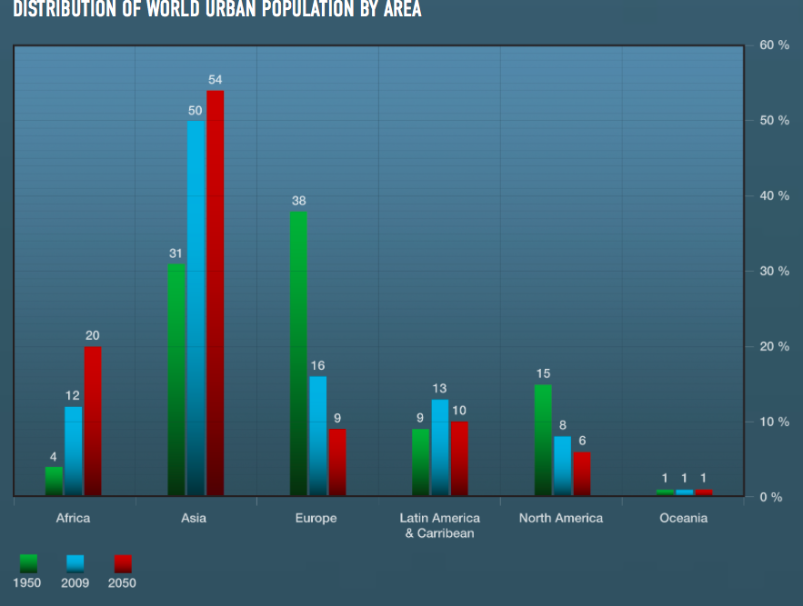

Distribution of world urban population by area

Previous Attempts to Solve the Issu

RAPID URBANIZATION AND MEGACITIES AN UNPRECEDENTED CHALLENGE, SINGAPORE TELLS SECOND COMMITTEE

Press Release

GA/EF/2840

RAPID URBANIZATION AND MEGACITIES AN UNPRECEDENTED CHALLENGE, SINGAPORE TELLS SECOND COMMITTEE

19981029

Rapid urbanization and the emergence of megacities represented an unprecedented challenge for the international community, the representative of Singapore told the Second Committee (Economic and Financial) as it concluded its consideration of sustainable development and international economic cooperation.

Across the world, the influx of migrants to urban centres was making greater demands on city infrastructures, he added.

Read more at: https://www.un.org/press/en/1998/19981029.gaef2840.html
Rapid City Expansion Unsustainable, Delegates Say, Urging Swifter Implementation of New Urban Agenda, as Second Committee Takes Up Human Settlements Program

Accelerated efforts to address rapid urbanization would be necessary in implementing the New Urban Agenda and realizing the Sustainable Development Goals, delegates said today, as the Second Committee (Economic and Financial) took up the United Nations Human Settlements Programme (UN‑Habitat).
“All aspects of human development as espoused in the Sustainable Development Goals, especially poverty eradication, sustained economic growth as well as combating climate change, will be realized in cities and rural areas,” said Kenya’s representative, adding that the New Urban Agenda was a “step in the right direction”.

Read more at: https://www.un.org/press/en/2017/gaef3483.doc.htm

Useful Links

Especially the interactive Graph: https://www.cnbc.com/2014/03/21/megacities-explosive-growth-poses-epic-challenges.html

Ways to fight against the informal sector: http://www.ilo.org/wcmsp5/groups/public/---dgreports/---integration/documents/publication/wcms_079142.pdf

https://en.wikipedia.org/wiki/Megacity

http://www.businessdictionary.com/definition/informal-sector.html

https://themoscowtimes.com/articles/megacities-face-mega-problems-15773

