HRC Topic 2: Measures to Protect Human Rights in the Light of Terrorist Attacks (e.g. in Iraq or Afghanistan)

Introduction
Terrorist attacks have always existed in this world, but these have increased enormously in recent years. The countries most affected are Afghanistan and Iraq, they have to suffer the consequences. Last year, more than 25,000 people died and 33,000 were injured in at least 11,000 terrorist attacks in more than 100 countries.
Since the 9/11 attacks in the US, bloody terrorist attacks have been carried out worldwide and terrorist attacks have been prevented. Because of this fact, the task of the Human Rights Council is to create framework conditions, by seeking solutions, so that we minimize terrorist attacks to the minimum and protect people.

Definition of key-terms
UNAMA ( = United Nations Assistance Mission in Afghanistan)
The United Nations Support Mission in Afghanistan, UNAMA for short, is a United Nations political mission based on UN Security Council Resolution 1401 of 28 March 2002. UNAMA assists the process of peace and reconciliation in Afghanistan.

UN Security Council
The United Nations Security Council, often referred to as the UN Security Council, is a United Nations body. It consists of five permanent and ten non-permanent members or states.

Taliban
The Taliban are a Deoband-Islamist militia that ruled large parts of Afghanistan from September 1996 to October 2001. From autumn 1994 they conquered large parts of Afghanistan. They sheltered jihadists from all over the world, including Osama bin Laden's al-Qaeda and numerous Central Asian and Pakistani groups. When the Taliban refused to extradite bin Laden after the 9/11 attacks, the US attacked Afghanistan and toppled it. Since 2002, the Taliban have been fighting Pakistan's new Afghan government and multinational troops stationed in Afghanistan.

IOM
The International Organization for Migration is a global aid organization in the field of migration, providing operational assistance programs for migrants at national and intergovernmental levels.

Daesch
The Islamic State is a terrorist militia active since 2003, with thousands of members seeking a "caliphate" declared jihadist state-building project.

Major Organizations Involved
For its part, the UN Security Council strongly condemned what it called “a wave of terrorist attacks” that killed at least 70 people and injured more than 200 across the country (Afghanistan).
The members of the Security Council condemn the heinous and cowardly terrorist attacks that took place in Paktia, Ghazni and Kabul in the strongest terms.
The Taliban has claimed responsibility for the attacks that reportedly targeted police and Government facilities across the country. The Council also reaffirmed that terrorism in all its forms and manifestations constitutes one of the most serious threats to international peace and security and that all states need to combat such threats by all means.
The Council also underlined the need to bring perpetrators, organizers, and sponsors of these acts to justice, urging all states to cooperate actively with the Government of Afghanistan and all other relevant authorities in this regard.
The United Nations condemns the 10 January terrorist attacks near Afghanistan’s Parliament in Kabul, and the residence of the Provincial Governor of Kandahar.
The United Nations expresses its solidarity with the people and Governments of Afghanistan and of the United Arab Emirates and calls for those responsible for the attack to be brought to justice. Indiscriminate attacks against civilians, including diplomatic envoys, are violations of human rights and international humanitarian law and cannot be justified.

The 15-member body (The General Assembly elected 15 States to serve on the Human Rights Council) went on to urge all States, in accordance with their obligations under international law and relevant Security Council resolutions, to cooperate actively with the Government of Afghanistan and all other relevant authorities in that regard. Humanitarian organizations provide life-saving assistance to the most vulnerable men, women and children in Afghanistan.
Since 1 January 2016, the UN Assistance Mission in Afghanistan (UNAMA) has recorded 850 civilian casualties – 273 killed and 577 injured – in 51 attacks targeting places of worship, religious leaders and worshippers.
Civilian casualties from these types of attacks since the beginning of 2016 represent nearly double the cumulative total documented between 2009 and 2015.The report highlights a disturbing pattern of attacks by anti-government elements directed at civilians in places of worship, particularly against Shi'a Muslim places of worship and congregations.
The report of UNAMA also documents the targeted killings of religious scholars and leaders regarded as pro-government, as well as the targeted killing of security personnel amidst other worshippers inside mosques.

They underlined the need to bring the perpetrators, organizers, financers and sponsors of the act to justice, and stressed the need to take measures to prevent and suppress the financing of terrorism, terrorist organizations and individual terrorists.
They reiterated that no violent or terrorist acts can reverse the Afghan-led process along the path towards peace, democracy and stability in Afghanistan, which is supported by the people and the Government of Afghanistan and by the international community.

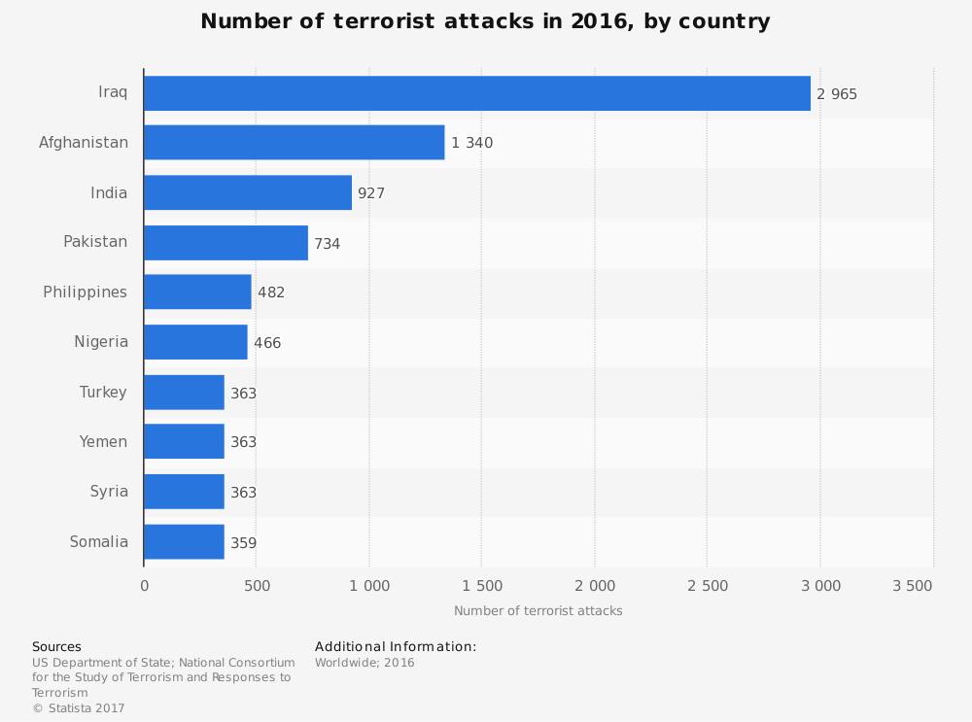

Attack in Kabul
The attack occurred in Kabul's Qalai Nazir neighbourhood, a predominantly Shi'a Muslim area, where civilians had gathered to commemorate a national day.
So far, about 100 casualties have been reported, including scores of civilians killed. Preliminary findings also indicate many children among the casualties.
The Mission reminds all parties that judges and staff of civilian courts – including the Supreme Court – are civilians. Attacks intentionally targeting civilians are tantamount to war crimes.
At least 20 civilians, mostly female employees of the Supreme Court, were killed when a suicide attacker detonated a device outside the Court. No person or group has claimed responsibility for the attack yet. The Council members reiterated their serious concern at the threats posed by groups such as the Taliban, Al-Qaida, and the Islamic State (ISIL), on the local population, National Defence and Security Forces and the international presence in Afghanistan.

This represents a critical, concrete step toward ensuring protection of civilians against the deadly threat posed by explosive hazards, and an opportunity for Afghanistan to support the global commitment to end suffering caused by landmines.
The explosions in Afghanistan, continue to endanger the health, safety and lives of the civilian population. Last year, UNAMA documented close to 1,700 casualties from these explosive hazards. Over half of all victims were children.

Previous Attempts to Solve the Issue
Such casualties are wholly preventable, and through mine action, they can be stopped.
The International Day for Mine Awareness and Assistance in Mine Action is commemorated annually on 4 April.
The members of the Security Council reiterated that any acts of terrorism are criminal and unjustifiable, regardless of their motivation, wherever, whenever and by whomsoever committed.
They stressed the need to take measures to prevent and suppress the financing of terrorism, terrorist organizations and individual terrorists, in accordance with resolutions 2199 (2015) and 2253 (2015).
They reaffirmed the need for all states to combat by all means - in accordance with the Charter of the United Nations and other obligations under international law, including international human rights law, international refugee law and international humanitarian law - threats to international peace and security caused by terrorist acts.
The UNAMA is encouraged that the Government of Afghanistan stressed that its security forces must ensure the principles of tolerance, professionalism and law-based behavior, welcoming the Government's commitment to prosecute and bring to justice the perpetrators of crimes against the people.

Iraq
According to data more than 3.3 million Iraqis have returned to their areas of origin, with most coming back to their homes in the governorates of Ninewa, Salah al-Din, Kirkuk and Anbar. In all, some six million Iraqis were displaced due to ISIL and the subsequent military operation to drive the group away.
As Iraq entered the recovery phase after three years of conflict, we should remember that real reconstruction of the country will not only be based on rebuilding infrastructure.
Provision of specialized support to all who survived the conflict is also needed, alongside reconstruction of infrastructure.
At the recent Kuwait International Conference for the Reconstruction of Iraq, the UN system launched a two-year Recovery and Resilience Programme, as part of which IOM will assist the Government of Iraq in addressing the multiple needs for rebuilding and reconstructing in the country.
The UN migration agency is also working on assistance efforts in areas of return, specific programmes include mobile community information centres, light infrastructure projects, housing rehabilitation, strengthening health facilities, relief kit distribution and livelihood support.
As of the some 2.5 million Iraqis yet to return to their origins, about half (51 per cent) are reportedly living in private settings – such as with families or friends – and about a quarter (26 per cent) in camps.
The presence of increasingly-deadly explosive hazards in liberated areas of Iraq are hindering efforts to rebuild and provide vital aid to families who are returning home:
The two-year Recovery and Resilience Programme is designed to fast-track the social dimensions of reconstruction and help ensure that people see tangible improvements in their daily lives at the start of the reconstruction process rather than waiting years to benefit from large-scale infrastructure projects and structural reforms.
During that time, tens of thousands of Iraqis lost their lives, hundreds of thousands lost their homes and livelihoods, and many women and girls were targeted for sexual violence on a staggering scale.
According to estimates, nearly six million Iraqis were forced to flee their homes.
Highlighting the path ahead, the UN chief urged priority be accorded to those who still remain displaced from their homes, to programmes aimed at empowering women and girls and said that the country’s reconciliation process must also include accountability for the crimes that have been committed.
The reconstruction programme focuses on urgent priorities – helping people who have suffered the most, revitalizing the areas at the highest risk of return to violence, and advancing broad political participation and inclusive social harmony.
The programme includes nine components.
Three will be implemented in high priority communities where violent extremism may possibly emerge unless steps are taken to restore community trust, build confidence in the Government and open economic opportunities.
The other components are national in scope. These focus on decentralizing basic services, promoting sustainable returns, providing support to survivors, accelerating community reconciliation and expanding political and social participation.
Separately, partners are seeking $569 million to provide life-saving assistance to 3.4 million highly vulnerable people across Iraq through the 2018 Humanitarian Response Plan.
While ISIL/Da’esh is being physically weakened, its presence in the virtual world is entrenched, posing a serious threat to international peace and security. It uses Internet propaganda both for radicalization and the recruitment of fighters, employing sophisticated manipulation and brainwashing techniques.
Noting that the flow of foreign terrorist fighters into Iraq and Syria had slowed due to military pressure and improved border control, those fighters returning home or relocating present another threat to global security, as they have the potential to re-energize existing terrorist networks or spur the growth of new ones.
Since summer 2014, Da’esh has lost 95 per cent of the territory it once controlled in Iraq and Syria and more than 7.5 million people have been liberated from its grasp.
Da’esh has exterminated or enslaved thousands of Muslims, as well as minority communities, particularly women and girls, in action amounting to war crimes and crimes against humanity, perhaps even genocide.
Among the prominent current concerns are the tensions between the Central Government and the Kurdistan Regional Government in the wake of a decision by the Kurdistan Region of Iraq to hold a unilaterally-declared independence referendum. The central authorities have rejected the referendum as unconstitutional and have taken steps to reassert federal authority over Iraq’s external border crossings, including the international airports in the Kurdistan Region of Iraq.
The Federal Supreme Court issued an opinion stating that the constitution does not provide for authorizing the secession of any component of Iraq’s federal system, and that the referendum was illegal.

Economic and social consequences
In 2016, nearly three-quarters of all deaths caused by terrorism occurred in just five states: Iraq, Afghanistan, Syria, Nigeria and Somalia. The global economic impact of terrorism is estimated to have reached $90 billion in 2015.
That year, terrorism costs amounted to 17.3 per cent of gross domestic product (GDP) in Iraq and 16.8 per cent in Afghanistan. Recalling how the Magna Carta established the principle of the rule of law 800 years ago, the Secretary-General said that at its core, human rights are a true recognition of common humanity.
First, he stressed the need for much stronger international cooperation, announcing that he intends to convene the first-ever UN summit of heads of counter-terrorism agencies to forge new partnerships and build relationships of trust.
Second is a sustained focus on prevention, which includes addressing the factors that radicalize young people and make terrorism a fateful option for them.
Terrorists are losing physical ground in Syria and Iraq, but gaining virtual ground in cyberspace. Facebook, Microsoft, Twitter and YouTube have launched an anti-terror partnership, the 'Global Internet Forum to Counter Terrorism,' aimed at thwarting the spread of extremist content online.

Conclusion
Facing threats of an unprecedented nature, states are scrambling to enhance efficiency of their counter-terrorist legislation. Without a firm basis in human rights, counter-terrorism policies can be misused and abused, e.g. to suppress peaceful protests and legitimate opposition movements.

Useful Links:
- https://news.un.org/en/story/2017/10/568852-un-strongly-condemns-terrorist-attacks-across-afghanistan
- https://news.un.org/en/story/2017/02/551092-security-council-un-mission-condemn-attack-near-afghanistans-supreme-court
- https://unama.unmissions.org/united-nations-security-council-statement-terrorist-attacks-afghanistan
- https://news.un.org/en/story/2017/06/558692-afghanistan-un-mission-urges-restraint-amid-ongoing-violent-protests-kabul
- https://news.un.org/en/story/2018/02/1003151
- https://news.un.org/en/story/2017/11/636352-unity-solidarity-and-collaboration-can-turn-tide-terrorism-bolster-human-rights

