## **https://astanatimes.com/wp-content/uploads/2015/09/iaea-logo.jpgMeasures to minimize the Emerging Problems due to a possible Nuclear Crisis**

Introduction

The International Atomic Energy Agency is an autonomous science and technology - based organization within the United Nations system and was created in 1957 in response to the deep fears and expectations generated by the discoveries and diverse uses of nuclear technology.

The objectives of the IAEA’s dual mission are to promote and control the Atom. According to this it has cooperated with its Member States and diverse partners since its beginning with the aim to achieve safe, secure and peaceful nuclear technologies.

With regard to these objectives it tries to protect human health and the environment from the dangers of ionizing radiation. Apart from that, the IAEA is strongly linked to nuclear technology and its controversial applications, either as a weapon or as a practical and useful tool.

“The Agency shall seek to accelerate and enlarge the contribution of atomic energy to peace, health and prosperity throughout the world. It shall ensure, so far as it is able, that assistance provided by it or at its request or under its supervision or control is not used in such a way as to further any military purpose.” *(IAEA)*

Ein Bild, das Tisch, Kuchen, Teller, Essen enthält.

Mit sehr hoher Zuverlässigkeit generierte Beschreibung

*(source: wikipedia.org)*

Member States Membership approved





Withdrew membership Non – members





Definition of the topic

The use of nuclear power plants is efficient although it has many risk factors. The crises in Chernobyl (1986) and Fukushima (2011) have shown us how dangerous the use of nuclear power plants may be. In order to minimize the emerging problems due to a possible nuclear crisis, the need for a concrete action plan to operate against problems which could possibly occur in a nuclear crisis is obligatory. Apart from that, measures to prevent a nuclear crisis are as important as the mitigation of a nuclear crisis.

General information on the issue

*Measures to Minimize the Emerging Problems due to a possible Nuclear Crisis*

The various effects of a possible nuclear crisis depict a large-scale threat to […] radioactive particles which are spread out inter alia in the atmosphere and reach the soil as fallout[1]. The radioisotopes are moved by wind currents in the form of radioactive clouds. Depending on the strength of the wind, other world regions may be affected, too.

Primarily, the *ground contamination* with several radioactive substances has damaging consequences on the human health. For instance, the radioisotope **Strontium 90** has a physical half-life of 28 years and it emits radiation. After the taking, it is metabolized similar to calcium so that it is absorbed by the osseous tissue[2] where it may remain for decades (50 years of the biological half-life). From the bones, Strontium contaminates the sensible bone marrow, which produces blood. Thus, leukaemia and further malignant ailments may occur. The radioisotope **Iodine 131** has a relatively short physical half-life of eight days. After entering our systems with nourishment, Iodine 131 comports the same way as regular iodine. The thyroid ingests iodine 131 but it destroys the thyroid tissue with beta - and gamma - rays until the radioactive substance finally decays. Although it inflicts lasting damages, such as thyroid cancer, whereby especially children are affected. **Caesium 137** has a physical half-time of 30 years. This radioisotope is metabolized similar to Kalium, hence it is distributed in the human body in a relatively even way. Caesium 137 radiates beta-rays prevalently. Indeed, the product of the decay is Barium 137, which also produces gamma-rays. Tumours can be caused practically in every organ.

The *infestation of the sea* is another possible problem emerging due to a nuclear crisis. If particles reach the sea or (see also catastrophe in Fukushima water) as e.g. fallout, they spread ~~out~~ and contaminate further regions of the world. ~~The~~ Sea life will be threatened and infested. According to a comprehensive report of the IAEA, the catastrophe in Fukushima (2011), aboveground nuclear weapon tests, the fallout in Chernobyl and the radioactive emissions of nuclear reprocessing plants like Sellafield or La Hague, are already considered to be the main contributors to the contamination of the global oceans. Further crises would aggravate our ecosystem, environment, economics as well as human health and daily life.

A significant occurring problem is *the contamination of provisions and potable water*. There is no safe low limit for radioactivity in food and drinking water. Even small amounts can cause a gene mutation and cancer. For instance, 22nd March 2011, during the Fukushima crisis, the IAEA warned against milk of the prefecture of Fukushima, which contained significant amounts of radioactive Iodine 131 and Caesium 137. Apart from that, fruits, vegetables, drinking water, beef, fish and sea food etc. were equally affected.

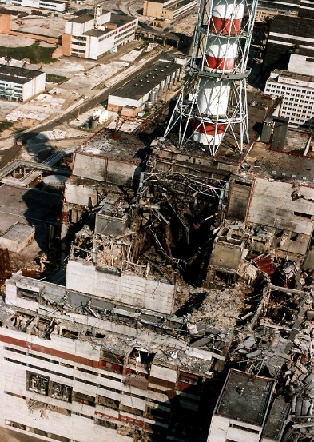

Furthermore, a nuclear crisis does not only harm human health through food intake but also through direct contact with radioactive rays. During a catastrophe like in Chernobyl (1986), the natural protective functions reached their limits. Strongest, Chernobyl challenged its liquidators the most. In the past years, many of them died. According to a statement from the international atomic energy agency 56 humans died immediately, most of them from the consequences of radiation sickness.

A nuclear crisis can be caused by various accounts:

* Radioactive waste
* Natural disaster
* Human influences
* Technical problems (no efficient building plans for the reactors)

**Historical Background**

1.Nuclear crisis: Atomic waste

In the course of the years there have always been different attempted solutions for the issue of atomic waste disposal.

A few states tried to decontaminate their atomic waste by disposing it in the oceans. It is assumed thatreclusively more than 10,000 tons of radioactive waste have been disposed of in the North Atlanticin the past. Above all the USA, Great Britain, Belgium, Switzerland and the former Soviet Union used this method with a frightening realization. The storages of atomic waste were dissolved by corroding salted water - the whole radioactivity of the storages has endangered the ecosystem of the oceans. Indeed, there is still radioactive waste on the ocean floors. This waste is a ticking time bomb.

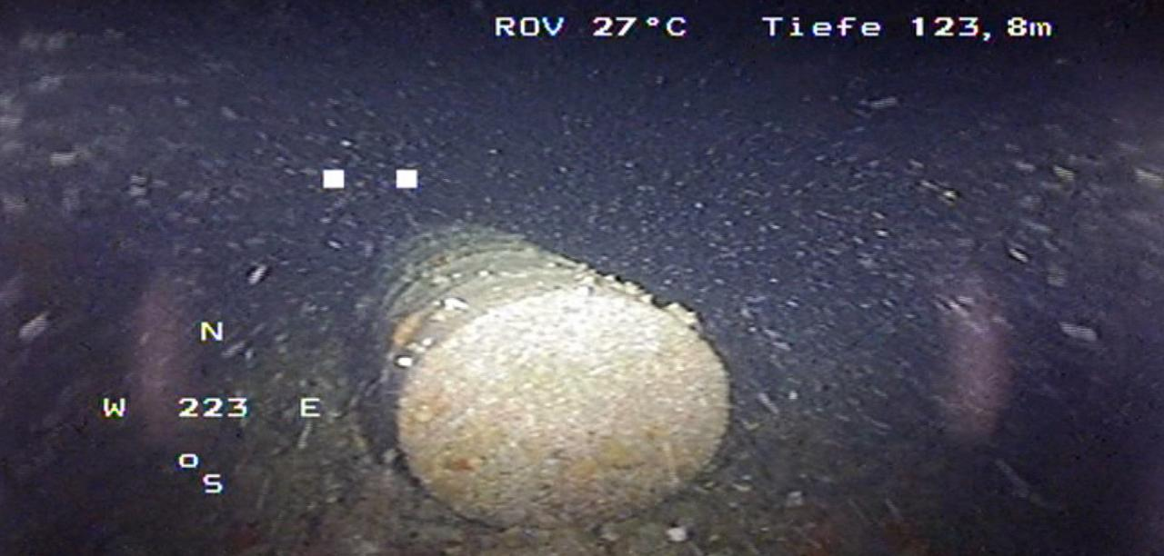

Intact storage of atomic waste in the front of the French coast. *(source: SWR)*

Another attempt at a solution was freezing the storages in the ice of the Antarctica. Indeed, this attempt was hindered by a variety of problems. First of all, the Antarctic Treaty determines that the Antarctica is an ecosystem which must be protected from all possible dangers. Furthermore, there are other aspects against this transaction: the drifting ice. It is impossible to predict how the storages will remain in the drifting ice, so they could escape at the edges of the ice blocks. In addition to this, the effects of global warming haven’t been considered yet.

The latest proposal assessed space. Disregarding the immense costs, there is another objection. Only one failed rocket start could cause a nuclear catastrophe as a large reactor accident.

2.Nuclear crisis caused by human or nature influence

The first reactor accident occurred in Chalk River seated in Canada on the 12th December 1952. The so-called NRX-reactor was used for a test when disaccords between operator and operating personnel, misuse, equipment tracking, false estimation and hesitant actions were leading to an oxyhydrogen explosion. As a result of this explosion radioactive material could leak out. The damaged reactor was buried and radioactively polluted water was pumped into an arenaceous sump to save the nearby river Ottawa. This accident is categorized as INES 5.

The Kyschtym-accident was one of the most fatal reactor accidents of all time with a categorization INES 6. The nuclear plant Majak was located in the former Soviet Union. The highly radioactive liquid tailings pond of nuclear fission was stored in tanks. The tanks must be cooled down because heat is released by radioactive disintegration. After the leak of one of the 300 cubic meter tanks in 1956 the contains of this tank started to dry. On 29th September 1957 a chemical explosion delivered a lot of radioactive material caused by an electric spark of an intern control unit. About 90 per cent of the radioactive material stayed locally, but about 10 per cent was spread by the wind to the north-east (fallout) and formed the’’Osturaltrace’’.

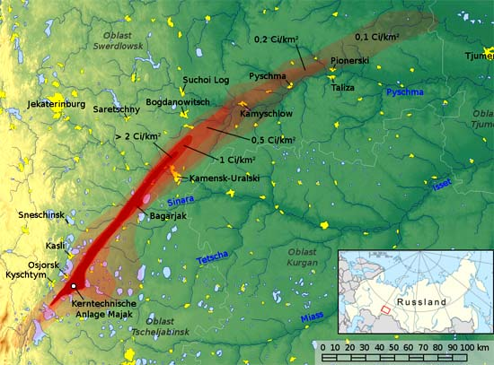

Osturaltrace of the Kyschtym-accident (source: Jan Rieke)

As a result of this serious accident about 10,700 people were forced to leave their homes. The accident was covered up by the government of the former Soviet Union until 1989.

The next fatal atomic accident occurred again in the former Soviet Union, in Tschernobyl in 1986. Its radioactive fallout could be measured throughout Europe.

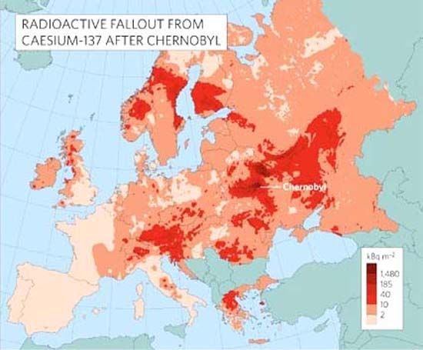

*(Source:J.Smith and N.A. Beresford "Chernobyl - Catastrophe and Consequences* )

This accident was called ‘’Super-Gau’’ and reached the category INES 7. The explosion of the reactor in bloc 4 was provoked by serious violations of prevailing safety regulations. The local environment was highly conterminated, so the first aid workers died immediately and until today there have still been victims of this Super-Gau. Since November 2016 the nuclear ruin was ensheathed with a new protective cover. Moreover, this protective cover should function for about 100 years and enable to salvage and decontaminate the atomic waste in the meantime.

The following catastrophe in Fukushima, Japan, was released by two natural disasters. On 11th March 2011 the Tohoku-earthquake started to threathen the power supply and the cooling pipes of the nuclear power plant Fukushima-Daiichi. The subsequent Tsunami caused by the Tohoku-earthquake destroyed the power supply and cooling pipes almost complete. On the same day there was an overheating of the fuel elements in three reactors and two fuel cooling installations, which caused many successive explosions. These explosions and several fires damaged the outside building envelopes, so the radioactive material could leak out into the environment.

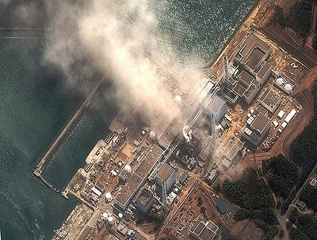

The nuclear power plant Fukushima-Daiichi a few seconds after the first explosions *(source Focus)*

International Nuclear Policy

After showing the whole world the destructive force of atomic bombs in Hiroshima and Nagasaki in the year 1945, US-President Eisenhower tried everything to give atomic energy a good reputation. So he founded a program called ‘’Atoms for Peace’’ in 1953 which should enable the entire world to get access to civil use of atomic energy.

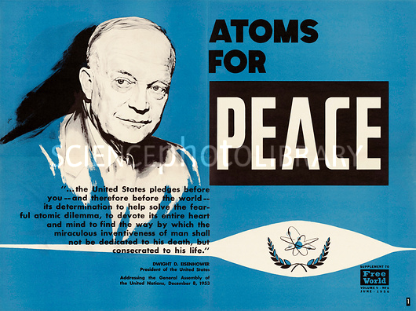

Excerpt of the Atoms for Peace speech and logo of Atoms for Peace

(source Sciencephotolibary)

Three years later the foreign ministers of Germany, France, Italy, Belgium, Luxembourg and the Netherlands followed the US-Nuclear policy with the European nuclear community (EURATOM). Congress has the aim to support the development of civil use of atomic energy in Europe. In the course of time not all states of the European Nation share the same opinion about the use of the atomic energy. Germany decided to phase out of nuclear energy. Other states like Italy, Austria, Denmark, Greece, Ireland and Portugal count on renewable energies. Merely France, Great Britain, Finland and a few East European states hold on to atomic energy.

The most recent developments of nuclear power plants are located in Asia. The IAEA counted 447 reactors in operation worldwide in August 2017.

Further Reading

I <https://www.iaea.org>

N https://www.nei.org/resources/fact-sheets

P https://planet-risk.org/index.php/pr/article/view/207/410

U https://www.ucsusa.org/nuclear-power/nuclear-power-accidents/history-nuclear-accidents#.WsugSJdCQ2w

W <https://en.wikipedia.org/wiki/Nuclear_and_radiation_accidents_and_incidents>

<http://www.world-nuclear.org/information-library/safety-and-security/safety-of-plants/appendices/chernobyl-accident-appendix-2-health-impacts.aspx>

1. Radioactive hail
2. Bone tissue