SOCHUM TOPIC 1: Media censorship and the incurring treatment of critically reporting journalists.

Introduction
Because of the ever more important role of the internet as the most essential information medium this topic is more relevant than ever before. The importance as a source of information and as the opportunity to practice freedom of speech is nowadays getting abused by governments of many nations. Often countries restrict the access to the internet completely or partly in order to suppress certain opinions or any opposition within their country. But still there are many independent journalists who try to exercise their right to free speech even though they endanger their own freedom and security. These journalists often have to undergo treatments that may include punishments such as imprisonment, in certain countries even physical punishments such as the death penalty.
But of course, even though the internet nowadays is the most essential medium, there are other media affected by censorship, too, such as newspapers, art, film productions, radio or television, which are often controlled by the governments having to stick to special rules, for example not to state any to the current government.
Definition of Censorship
Censorship is the suppression of speech, public communication, or other information, on the basis that such material is considered objectionable, harmful, sensitive, politically incorrect or "inconvenient" as determined by government authorities or by community consensus.
Defined by Wikipedia/Censorship
Censorship is the official prohibition, restriction or control of the free expression of opinions, ideas and information in order to prevent the publication of special materials containing these opinions or information. The level of censorship is always highly connected to the certain level of freedom of speech in a country.
Defined by the Chair

Affected Nations
Nations most affected by censorship or other restrictions of the freedom of speech are in South East Asia, but also Russia and big parts of Africa. In many of these countries journalists perform their work even though they are not able to practice their right to freedom of speech without fear of punishments for trying to state their opinion in the media, mostly on the internet. The map below shows the level of freedom of speech all over the world, thereby indirectly referring to the situation for critically reporting journalists.
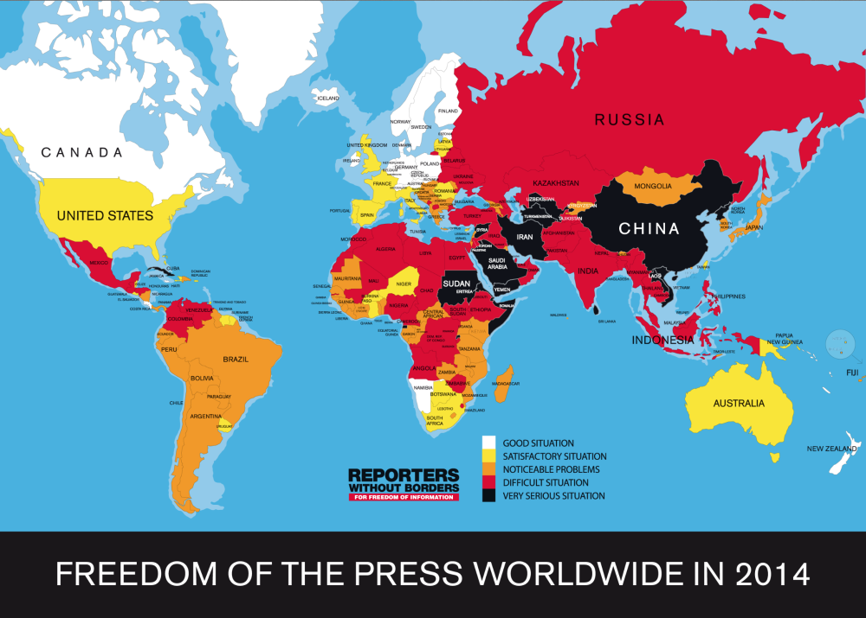

http://www.bakkalchatv.com/news/the-nordic-countries-are-on-the-top-of-world-press-freedom-index

Most affected countries:
Eritrea: In Eritrea, only state media are allowed having to follow strict regulation and censorship by the government. No international correspondents have been approved since 2007, but even those journalists working for the state media live in fear that one of their reports is going to be interpreted as critical of the regime. Since 2001 no independent or private reports have been permitted and many journalists are still in prison since that time.
Democratic People’s Republic of Korea: North Korea has an article in its constitution that states the freedom of speech, but tough measures are used to restrict this right. Nearly all media forms are controlled by the governmental institution Korean Central News Agency. This agency controls all newspapers and broadcasts into the country. The internet is severely restricted and only accessible for the political elite and, under some specific terms, for schools but only in a rigidly censored version.
Saudi Arabia: The government of Saudi Arabia even tightens its restriction of freedom of speech with the help of censorship. An amendment to their press laws was added which allows the government to punish all reporters and journalists who are involved in the publication of material that contradicts the policy of sharia, supports foreign ideas or other material that would threaten its national security.

Position of the P5 nations
United Stated of America: The freedom of speech and the freedom of press in the USA is stated in the very first amendment to the constitution
“Congress shall make no law respecting an establishment of religion, or prohibiting the free exercise thereof; or abridging the freedom of speech, or of the press; or the right of the people peaceably to assemble, and to petition the Government for a redress of grievances.”
The situation in the country for critically reporting journalists is very good as the United States is known for its satire culture. The only news getting censored online are those classified as illegal, e.g. child pornography.
United Kingdom and northern Island: In the UK the right to free expression is stated in the ^{10th} constitution article and so there is nearly no restriction to the media or journalists’ work. But some material gets censored online, such as pornography in general or the visualization of violence. However, there are intense discussions if these regulations should be repealed.
France: In France the media are free and the freedom of press is ensured by the law. Even though there are nearly no restrictions to the work of journalists there are still some laws, e.g. privacy laws, that make their work difficult. Nevertheless, they don’t have to fear any serious punishments.
People’s Republic of China. The situation in China concerning the freedom of press and the resulting situation for journalists is very critical. The government has restricted sensitive events. The news are nearly completely controlled by the regime, independent journalists are not tolerated and live in constant fear of getting arrested for their work. China has nearly the largest number of journalists who are imprisoned in the world. Also, the Internet is getting censored by the government on a large scale. For example, nearly all important, western social platforms are forbidden and banned such as Facebook, Twitter or YouTube. Alternative platforms were established by the government, but they are completely under the control of the propaganda ministry.
The Russian Federation: There are some serious problems concerning the freedom of press. Most of the media have been under the control of the government since the election of Vladimir Putin in 2000, and critically reporting companies are getting pressured regularly and are often in danger of getting shut down. Individual reporters and especially independent bloggers who give negative reports about the regime must also fear to get arrested or even targeted for assaults or violated in other ways. There are also really strict laws that allow the government to ban or censor online sites which criticize the cabinet.

Measures already taken by the UN:
There have been several attempts to tackle the issue of censorship especially with the rise of the internet as the most important medium for the exchange of opinions and information, but there are large parts of the world where censorship is still a huge problem for journalists who try to do their job and inform the population of their country about grievances and incidents of abuse. Attempts have been made to extend the basic human rights, such as the freedom of press, to the internet. But due to the fact that this hasn’t been able to tackle the problem completely, this topic still needs to be discussed and approached with the objective to ensure that journalists can do their work without living in fear and insecurity.

Useful links:
http://www.bakkalchatv.com/news/the-nordic-countries-are-on-the-top-of-world-press-freedom-index
https://www.weforum.org/agenda/2016/12/freedom-on-the-net-2016-where-are-social-media-users-under-pressure/
https://www.popsci.com/un-resolution-expands-basic-human-rights-to-internet https://rsf.org/en
https://gijn.org/2016/11/01/un-report-the-assault-on-reporting/
https://www.weforum.org/agenda/2016/12/freedom-on-the-net-2016-where-are-social-media-users-under-pressure/
https://cpj.org/2015/04/10-most-censored-countries.php#1

