World Health Organization Topic 1: Combating the Illegal Medical Black Market with Special Regard to Organ Trafficking

I. INTRODUCTION
Actually, organ transplantation is an effective therapy for end-stage organ failure and is performed all over the world. In accordance with GODT (Global Observatory on Donation and Transplantation) about 126,670 organs were transplanted in 2015. Every ten minutes a patient is added to the national transplant waiting list and on average 20 people die each day while waiting for the life saving transplant (UNOS- United Network for Organ Sharing ). The access to transplants depends on the national situation, the cost of healthcare, the level of technical capacity and, most importantly, the availability of organs.
The demand for donor organs has globally increased due to improvements in transplant medicine and rising vital organ failure. Nevertheless, the unavailability of organs led to a major organ shortage crisis. This shortage is one of the main reasons for the massive development in organ trade (mainly kidneys). Organ trafficking has developed into a global issue.

II. DEFINITION AND FACES OF ”TRAFFICKING IN HUMAN ORGANS“
The term “Trafficking in human organs“ covers different illicit activities and phenomena demonstrating similarities. These definitions also relate to different frameworks.

II.I TRAFFICKING IN HUMAN BEINGS FOR ORGAN REMOVAL (THBOR)
THBOR refers to the trafficking in persons for the purpose of organ removal. It is a violation of fundamental Human Rights, mostly performed by transnational organized crime networks.
THBOR is clearly defined in the United Nations Protocol to prevent, suppress and punish trafficking in persons, especially women and children, supplementing the UN Convention on Transnational Crime Res 53/111, 2000. ”Trafficking in persons shall mean the recruitment, transportation, transfer, harbouring or receipt of persons, by means of the threat or use of force or other forms of coercion, of abduction, of fraud, of deception, of the abuse of power or of a position of vulnerability or of the giving or receiving of payments or benefits to achieve the consent of a person having control over another person, for the purpose of exploitation. Exploitation shall include, at a minimum, the exploitation of the prostitution of others or other forms of sexual exploitation, forced labour or services, slavery or practices similar to slavery, servitude or the removal of organs.“

II.II ORGAN TOURISM / TRANSPLANT TOURISM

Transplant Tourism is a frequent way to trade organs and focuses in contrast to THBOR more on the recipient of an organ, thus patients who are looking for an organ travel abroad to receive an organ. This international movement of potential recipients is frequently arranged by healthcare providers. The supplier („vendor“) agreed in removing his organ and is not transported across boundaries. Due to the fact that the vendor is mostly willing to have his/her organ removed because of financial aspects it still cannot be seen as a voluntary decision. Moreover, the supplier is paid.

II.III TRAFFICKING IN ORGANS, TISSUES AND CELLS (OTC)

OTC is a crime where organs, tissues and cells are removed illegally from either living or decreased persons (donors) . Therefore, it covers the term of buying and selling body parts either from living persons or stealing organs from deceased persons, e.g. at autopsy. These actions are clearly banned in different international conventions(CETS No. 164, 1997, CETS No. 186, 2001, WHO Guiding Principles on Human Cell, Tissue and Organ Transplantation ) and regional legislation.

II.IIII TYPICAL CHARACTERISTICS AND BACKGROUNDS OF ORGAN RECIPIENTS AND ORGAN SUPPLIERS/ VICTIMS

II.IIII.I ORGAN RECIPIENTS
- Long waiting lists and too long waiting times on list -> Introduction I.
- No permission to be added to the list or being removed because of health prerequisites
- No possibility of live donation ( relatives)
- No access to transplantation due to local medical conditions
- Belonging to minorities, e.g political issues
- Organ recipient’s economic situation is frequently better than the organ supplier’s situation

II.IIII.II ORGAN SUPPLIERS/ VICTIMS
- People lacking education and medical basic knowledge
- Vulnerable persons
- Inhabitants of less developed countries (”organ-exporting countries“ )
- Young age groups
- Inhabitants of countries with a bad legislative system concerning trafficking in human beings
- The organ supplier as victim - since not actively involved in organ trafficking - needing protection and care

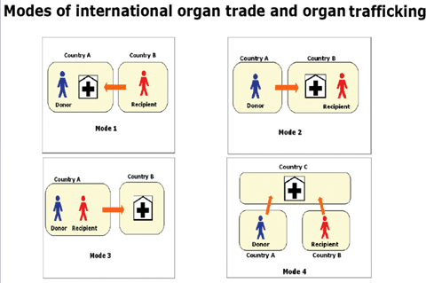
Source: Shimazono 2007 WHO

III. GLOBAL SPREAD OF TRAFFICKING / ORGAN -EX AND -IMPORTING COUNTRIES
In the 19th century trafficking in human organs (mainly kidneys) was mainly performed in India and Southeast Asia. Patients receiving the kidneys came primarily from the Gulf States, Japan and Asian countries. Moreover, there were single reports handed in by the USA and EU describing patients who travelled abroad to receive kidneys. Since 2000 trafficking in organs has developed into a global issue. Today the political instability and economic crisis in Latin America, North Africa and many other regions has created new opportunities for traffickers since Eastern Europe, the Philippines and India have already implemented a stricter law against trafficking in human being.

III.I ORGAN EXPORTING COUNTRIES
India was a globally known exporting country. Mainly kidneys from local suppliers were transplanted to paying recipients from other countries. Although India implemented a law banning the organ trade (The Human Organ Transplantation Act of 1994), which led to a decreasing number of foreign recipients, the medical black market and organ market is definitely still existing. According to the WHO, about 2,000 Indians sell one of their kidneys each year. India is part of the world’s biggest medical black markets for organ trade.
Pakistan is internationally known for illegal kidney trade. Unfortunately, there are no official data for the number of people who sold their kidneys but according to informed officials the number of kidneys exceeds 1,000 each year. ”85% of all organ trafficking cases were reported in Pakistan“ - Babar Nawaz Khan.
According to the World Health Organization, the Philippines are also identified as one of the global hotspots for medical black market and organ trafficking. In 2008 a ban was implemented by the Philippines, since kidney transplants increased more than 60% from 2002-2006, thus transplants to foreigners are banned and participants have to pay about $48,000 or could be sent to jail for up to 20 years.
In 2010 Egypt was ranked among the top five countries for organ trafficking by the World Health Organization, although there were bans already dealing with organ trafficking. The bans prohibit transplants to foreigners and legalizes transplantations from deceased persons in certified hospitals and under special conditions. Unfortunately, the crisis concerning organ trafficking has not been mitigated by the state. The law has not been enforced and penalties have been lax in practice. The issue of organ trade in Egypt is increasing. Usually organs are stolen from corpses in non-governmental and governmental hospitals. Approximately 100-200 illegal transplants are performed each year.
According to experts between 60,000-100,000 transplants were performed in China each year. The majority of transplants concerns livers, hearts and kidneys. Most of the transplant organs have been eviscerated from executed prisoners, many of them prisoners of conscience. According to the Chinese government itself about 10,000 transplants are carried out annually. Moreover, in accordance with the Chinese government, China moved from relying on organs of prisoners to the ”largest voluntary organ donation system“ in 2014 although China claims to have strict laws and regulations on this issue. China seems to be a big part of the international illegal organ trafficking system.
There are several other reports about countries where kidneys and other organs are sold, including Bolivia, Brazil, Iraq, Israel , the Republic of Moldova, Peru, Colombia, Kosovo and Turkey. However, kidney trade is legal and regulated by the government in Iran.

III.II ORGAN IMPORTING COUNTRIES

The term organ-importing countries is here defined as the country of origin of patients traveling abroad to receive an organ.
According to the organization ”Organs Watch“, Australia, Canada, Israel, Japan, Oman, Saudi Arabia and the USA are the major organ-importing countries.
Transplant tourism has become a global issue, thus many other countries and regions are affected.

Country (year) | Numbers of transplants
Malaysia (2004) | • 132 renal transplants outside the country (China, India)• 42 renal transplants in Malaysia23
Oman (2003) | • 83 living nonrelated renal transplants outside the country (Iran, Pakistan)• 8 renal transplants inside the country24
The Republic of Korea (2004) | • 73 overseas transplants in China in 2003; 124 as of the end of August in 200422
Saudi Arabia (2006) | • 646 renal transplants outside the country• 351 renal transplants inside the country25
Taiwan, China (2005) | • 450 transplants in other Chinese areas; 300 for renal transplants, the rest for liver, heart, lung transplants3

Table: The annual number of patients going overseas for transplants ( source: WHO)

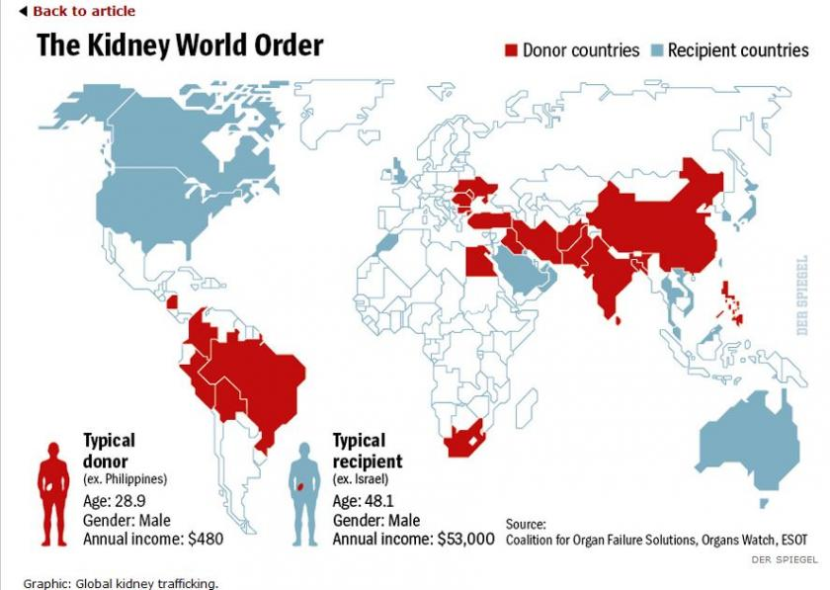

IV. MEASURES TAKEN AGAINST ORGAN TRAFFICKING
The World Health Organization and its World Health Assembly adopted the first version of the ”Guiding Principles on Human Cell, Tissue and Organ Transplantation“ (WHA44.25), as well as ( WHA42.5) and (WHA44.5) in 1991. The Guiding Principles were updated in 2008. The current Guiding Principles were adopted in 2010 (WHA63.22) adding ”measures to protect the poorest and vulnerable groups from transplant tourism and the sale of organs and tissues“. The WHO-standards and principles provide advice to healthcare providers but, unfortunately, they are not legally binding.
In October 2000 the World Medical Association adopted a statement by the 52nd WMA General Assembly in Edinburgh promoting guidance to healthcare providers in issues relating to organ donation and transplantation. One of the main topics focused on non-commercialization of human organs. “Payment for organs must be prohibited. A financial incentive compromises the voluntariness of the choice and the altruistic basis for organ donation. Furthermore, access to needed medical treatment based on ability to pay is inconsistent with the principles of justice. Organs suspected to have been obtained through commercial transaction must not be accepted for transplantation. In addition, the advertisement of organs in exchange for money should be prohibited.“ (§30) The statement was revised by the 57th WMA General Assembly in October 2006 again prohibiting commercialism. It has no legally binding character. Unfortunately, the statement was rescinded at the 65th WMA General Assembly in Durban.
The Declaration of Istanbul was first published in 2008. It issues transplant tourism, commercialism and trafficking, and provides guidelines to healthcare providers, moral principles and proposals to combat and prevent the issue. The cause for establishing the Declaration in 2008 was the increasing awareness that organ trafficking developed into a global issue. The DOI has been supported by 111 organizations, including UNOS and several others. Because of this declaration many countries were induced to implement stricter laws and major changes in organ trafficking policy. However, the Declaration of Istanbul does not have a legally binding character.
In 1978 the Committee of Ministers of CoE adopted the Resolution (78)29 “Harmonization of legislations of member states relating to removal, grafting and transplantation of human substances“ prohibiting any human substances from being used for profit. This is also not legally binding. However, it was the basis foundation for the Convention for the Protection of Human Rights and Dignity of the Human Being with regard to the Application of Biology and Medicine: Convention on Human Rights and Biomedicine, which was adopted in 1997 (CETS no.186). All member states who have signed and ratified this Resolution are legally bound by it. The Resolution focuses on citizens’ integrity, rights and fundamental freedoms in relation to biology and medicine.
In 2002 an additional Protocol to the Convention on Human Rights and Biomedicine, concerning Transplantation of Organs and Tissues of Human Origin (CETS No. 186) was implemented. The additional protocol focuses on the protection of individuals, especially in the field of organ translation and donation. Moreover, the additional protocol formulates sanctions and is also legally binding. In addition to the CoE several Recommendations issuing these problems were implemented.
The United Nations Palermo Protocol “UN Protocol to prevent, suppress and punish trafficking in persons, especially women and children, supplementing the UN Convention against transnational organized crime“ against transnational organized crime focuses on THB ( Trafficking of human beings). Moreover, it includes definitions focusing on trafficking for the removal of organs as a form of exploration.
The Convention on action against trafficking in human beings, (CETS 197) was adopted in 2005 and includes the definition of THB described in the Palermo Protocol and includes the removal of organs as a form of THB, no matter if the supplier has given consent or not. Furthermore, it includes some additions to the Palermo Protocol. The Convention is legally binding for all member states that have signed it.
The “Council of Europe Convention against Trafficking in Human Organs“ (CETS no. 216) is another convention, which calls governments to establish the illegal removal of either living or deceased persons as a criminal offense and provides protection and prevention measures.

V. EFFECTS AND CONSEQUENCES
It is frequently reported that the death rate of recipients and suppliers in cases of organ trade increases the usual international death rate in relation to transplantations. However, there are some studies showing similar death and survival rates in comparison to local results, thus generalizations are difficult. Nonetheless, many studies report a higher incidence of medical complications such as the transmission of HIV and hepatitis B and V viruses. Moreover, paid kidney donors do not get a proper postoperative care, due to poverty.

VI. LINKS
http://www.europarl.europa.eu/RegData/etudes/STUD/2015/549055/EXPO_STU(2015)549055_EN.pdf
https://onlinelibrary.wiley.com/doi/full/10.1111/j.1600-6143.2008.02200.x
http://www.who.int/bulletin/volumes/85/12/06-039370/en/
http://www.drze.de/in-focus/organ-transplantation/modules/organhandel?set_language=en
Different local articles concerning organ trade in affected regions

