UNESCO – Measures to Enable and Improve Access to Education for Children in Developing Countries
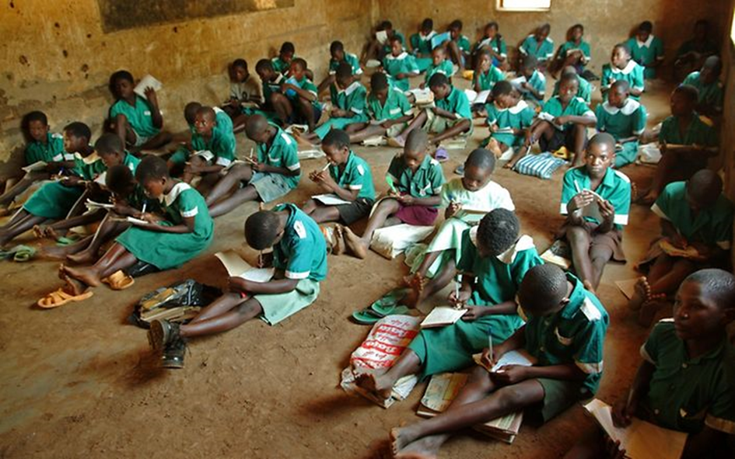

Structure:
- UNESCO
- Information on the committee
- Introduction to the topic and current situation

- Right to Education
- Legal bases of education
- Why is it so important?

- Possible Consequences of Regressive Education

- Measures to Improve Access to Education in Developing Countries

- Useful Links

I. UNESCO
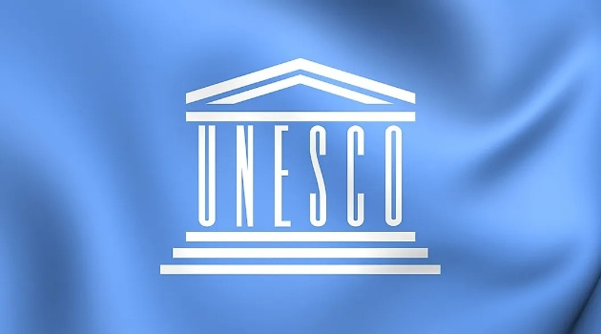
- The United Nations Educational, Scientific and Cultural Organization, otherwise known as UNESCO, operates under the governance of the United Nations. From its global headquarters in Paris, UNESCO aims to promote peace and security by encouraging global reforms in the areas of education, science, communication and culture, preserving the latter, as well as fostering increased respect for human rights and freedoms.
UNESCO has been at the forefront of scientific research and development since its inception. The organization seeks to establish national and regional science policies, particularly in developing countries, and establish research organizations to promote biodiversity, engineering and education, as well as addressing the challenges of natural disaster and climate change.
Other important initiatives include the preservation of cultural heritage sites, promoting social integration through sport activities, promoting accessible healthcare as a basic human right, and building global "knowledge societies" by providing worldwide access to digital information and encouraging international journalistic freedom.

II. Introduction to the topic and current situation
Here is a quick overview of the situation of education:
- About 258 million children and youths are out of school, according to UIS data for the school year ending in 2018. The total includes 59 million children of primary school age, 62 million of lower secondary school age and 138 million of upper secondary age.
- 155 countries legally guarantee 9 years or more of compulsory education
- Only 99 countries legally guarantee at least 12 years of free education
- 8.2% of primary school children do not go to primary school. Only six in ten young people will be finishing secondary school in 2030. The youth literacy rate (15-24years) is 91.73%, meaning 102 million youths lack basic literacy skills.
- What is more, a massive gap exists between boys and girls. In India, for instance, for every 100 boys not enrolled in primary school there are 426 girls, or in Somalia, where 95 percent of girls at the age of 7-16 have never been to school.
- When education is shown as an average number of years at school and respective levels of achievement, the developing world is about 100 years behind developed countries. These poorer countries still have average levels of education in the 21st century that were achieved in many western countries by the early decades of the 20th century. In developed countries, adults have achieved an average of 12 years of school, compared with 6.5 years of school for those in developing countries.
- Discrimination against various groups is often reported.

In the light of these facts, there are obvious concerns, meaning that one needs to examine the reasons. The first is the ongoing corruption: Despite schooling fees being outlawed in many developing countries, an average of 44% of parents still report paying fees for their offspring’s studies.
The lack of financial knowledge of head teachers, leads to mismanagement and waste of already limited resources.
Apart from corruption, economical factors play a big role. Many families rely on their children as a working force, as they need them to finance food and other necessities. Likewise, affording supplies and uniforms is impossible for millions of families.
Another common problem is power abuse. This can also be related to corruption or, even worse, people in leading positions abuse their power to commit sexual abuse.

III. Right to Education
- Legal bases of the Right to Education
There are a variety of legal bases ensuring a right to education, including the International Covenant on Economic, Social and Cultural Rights which recognizes a right to free, compulsory primary education for all, an obligation to develop secondary education accessible to all with the progressive introduction of free secondary education, as well as an obligation to develop equitable access to higher education, ideally by the progressive introduction of free higher education. In 2021, 171 states were parties to the Covenant.
Another legal basis is article 26 of the Universal Declaration of Human Rights from 1948, stating that "Everyone has the right to education. Education shall be free, at least in the elementary and fundamental stages. Elementary education shall be compulsory. Technical and professional education shall be made generally available and higher education shall be equally accessible to all on the basis of merit. Education shall be directed to the full development of the human personality and to the strengthening of respect for human rights and fundamental freedoms. It shall promote understanding, tolerance and friendship among all nations, racial or religious groups, and shall further the activities of the United Nations for the maintenance of peace. Parents have a prior right to choose the kind of education that shall be given to their children."

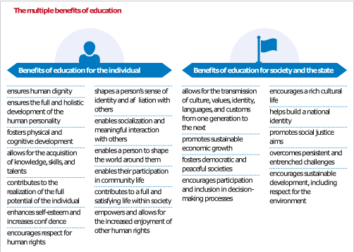

- Why is this right so important?

Education is fundamental to human dignity by ensuring the full and holistic development of the human personality; fostering physical and cognitive development; allowing for the acquisition of knowledge, skills, and talents; contributing to the realization of the full potential of the individual; enhancing self-esteem and increasing confidence; encouraging respect for human rights; shaping a person’s sense of identity and affiliation with others; enabling socialization and meaningful interaction with others; enabling a person to shape the world around and thereby participating in community life; contributing to a full and satisfying life within society; and empowering and allowing for the increased enjoyment of other human rights.
By UNESCO - https://unesdoc.unesco.org/ark:/48223/pf0000366556, CC BY-SA 3.0 igo, https://commons.wikimedia.org/w/index.php?curid=87430438

IV. Possible Consequences of Regressive Education
The consequences of not having access to quality education are quite severe.
According to a report of the International Monetary Fund’s Fiscal Monitor, less-educated men statistically live between 4 and 14 years less than their well-educated counterparts.

Furthermore, you are much less likely to escape poverty, as wages are lower and unemployment is a very real prospect. These are numbers published by the OECD, showing the effect of Education on one’s employment status:
83% of people with a university degree are employed;
74% of people with an upper secondary or non-university postsecondary education (e.g. a trade qualification) are employed;
56% of people without an upper secondary education are employed.

Additionally, Education has a great impact on general health. Primary education is important for learning about personal health and hygiene, as education is how health professionals and governments communicate important information to society. Poor health and hygiene is a serious issue in societies where large amounts of the population lack an education.
As stated by the UNHCR, simply educating all girls to a secondary school level would decrease worldwide deaths from pneumonia, diarrhea, and malaria by 49%.

Finally, it should not be left unmentioned that bad education leads to an increasement of inequality: Countries where women are less educated continue to perpetuate gender inequalities from one generation to the next. Women who are less educated tend to have babies at a younger age. According to the United Nations Girls’ Education Initiative, each year a girl is out of school increases national fertility rates by 10 percent. Women who have children after receiving a secondary school education tend to have healthier babies. The UNGEI argues that these women’s higher levels of education mean “they will know how to properly care for” their babies. Furthermore, women with a lower education are less likely to raise their voice when it comes to political and community issues that affect them. Education is also a space where gender stereotypes are challenged, which may also lead to decreased gender inequality. If girls and boys are educated side-by-side, such stereotypes may also disintegrate.

V. Measures to Improve Access to Education in Developing Countries
To help improve access to Education it is crucial to abolish fees for education and make it as affordable as possible. This could be achieved by lowering or abolishing the cost of school uniforms and supplies and as mentioned before, by abolishing school fees. It is important to make sure that corruption cannot take foot, ensuring that fees are not being brought in illegally. It is important to ensure that corruption cannot gain a foothold and that fees are not collected illegally.

Also, the school system needs to be revised, so that children learn important and qualitative knowledge. Investing in test scores and achievement is no longer a useful way to focus on education, according to the Stanford Social Innovation Review. A new educational model should combine traditional content with important financial, health and administrative skills. Students should practice teamwork, leadership and critical thinking. They should also gain exposure to entrepreneurship projects such as identifying and exploiting market opportunities through business ideas such as community recycling. This shift away from standardized learning will prepare students to make a positive impact on the social and economic wellbeing of their communities.

Moreover, it is important to improve resources and training of teachers. This would include implementing computer-assisted learning and training teachers on how to use it properly. Computer-assisted learning will inevitably improve education in developing countries and enhance the educational experience of both teachers and students.
VI. Useful links
The official website of UNESCO contains lots of information: https://www.unesco.org/en
Helpful when trying to come up with solutions and to get a grasp of what is happening:
https://www.eib.org/en/essays/invest-in-education-in-developing-countries
https://www.borgenmagazine.com/education-in-developing-countries/
https://www.kudroli.org/blogs/the-importance-of-education-in-developing-countries
https://www.worldbank.org/en/news/immersive-story/2019/01/22/pass-or-fail-how-can-the-world-do-its-homework
You might also find it helpful to take a look into the bibliography:

Bibliography
https://helpfulprofessor.com/lack-of-education/
https://www.brookings.edu/blog/education-plus-development/2015/04/29/the-global-100-year-gap-in-education-standards/
https://www.borgenmagazine.com/education-in-developing-countries/
https://www.eib.org/en/essays/invest-in-education-in-developing-countries
https://www.international.gc.ca/world-monde/issues_development-enjeux_developpement/human_rights-droits_homme/education.aspx?lang=eng
https://en.wikipedia.org/wiki/Right_to_education
https://borgenproject.org/10-key-aspects-of-girls-education-in-developing-nations/
https://en.unesco.org/news/what-you-need-know-about-right-education
https://reliefweb.int/organization/unesco
https://unesdoc.unesco.org/ark:/48223/pf0000380398
https://de.wikipedia.org/wiki/UNESCO#Organisationsstruktur_der_UNESCO
https://de.wikipedia.org/wiki/UNESCO

