HRC-MEASURES TO APPROACH THE ELIMINATION OF THE RECRUITMENT AND USE OF CHILD SOLDIERS

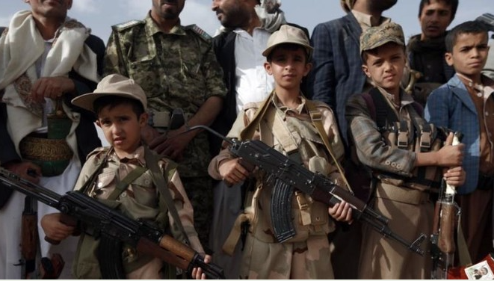
This picture shows four child soldiers under the age of 13. They are fighting on the front lines in the Middle East and are exposed to violence and terror every day. Right now there are about 250,000 children in the same situation all over the world.

Structure:

- Human Rights Council
- Introduction to the Topic and Definition of Child Soldiers
- Use and Recruitment
- Global Use and Recruitment of Child Soldiers
- by Governments
- by Non-State Armed Groups
- Current Legal Situation
- Conflict with the Human Rights
- Definition of “Human Rights“
- Article 26: Education
- Article 25: Health and Medical Care
- Lasting Consequences for Children who are Recruited and Used in Armed Conflicts.
- Physical Consequences
- Psychological Consequences
- Steps against the Recruitment and Use of Child Soldiers from
- Approaches by Governments
- Approaches by NGOs
- Useful Links

1.Human Rights Council
The Human Rights Council is an inter-governmental body and part of the United Nations system. The Human Rights Council has 47 member states and is based in Geneva, Switzerland. On the 15th of March 2006 it was founded with the purpose to protect, enforce and promote human rights.
The Human Rights Council meets three times a year or at any time if there is evidence of human rights violation to discuss measures against these violations.
The Human Right Council has the important task to ensure a fair, equal and good life for every human. By protecting the human rights the Council wants to make sure that every human being has the same opportunity for a fulfilled and happy life. By promoting the Human rights the Council wants to make sure that people treat each other as equals and values each other.

2. Introduction to the Topic
a) Definition of Child Soldiers
“A child associated with an armed force or armed group refers to any person below 18 years of age who is, or has been, recruited or used by an armed force or armed group in any capacity, including but not limited to children, boys and girls, used as fighters, cooks, porters, spies or for sexual purposes”
(Source :Paris Principles on the Involvement of Children in Armed Conflict 2007)

Important with this definition is to acknowledge, that not only children who are forced to fight for the armed forces are included in this definition. Children who are recruited, for example as spies, or are used for sexual purposes are also part of this threatening issue. Furthermore, it is important that there is no exception made because of gender, which means that every underaged boy or girl is considered by this definition.
b) Use and Recruitment
Right now there are thousands of children fighting in armed conflicts. Some children are forced to fight and others join the armed forces because of desperation, hunger and with the hope that this will ensure a better life for them. Sadly, the truth is that many children die in these armed conflicts or carry lasting physical and/or psychological consequences of the violence they have to witness and endure. It was reported that last year alone 500 child soldiers died while being forced to fight side by side with armed groups in civil conflicts and or wars. Important is to consider that this number does not include children who were killed because of refusing to fight, children who died while working for the armed groups as spies and porters, etc.

3. Global Use and Recruitment of Child Soldiers
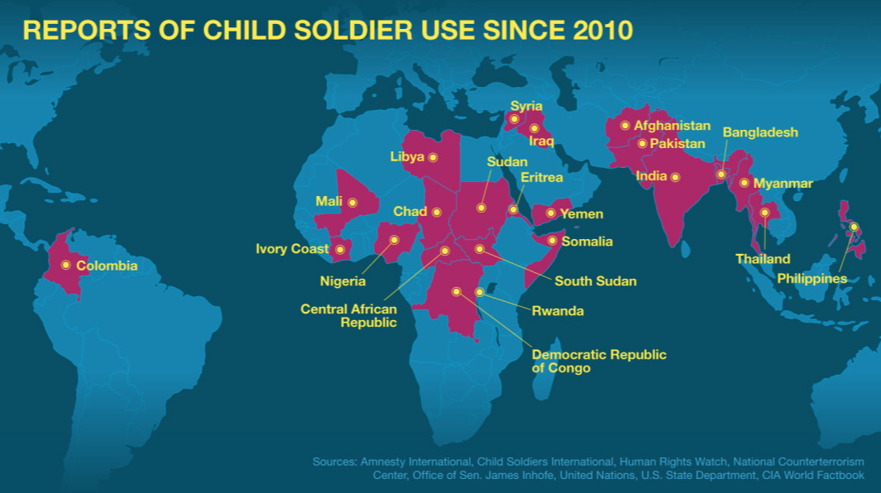

Right know there is an estimated amount of 250,000 children in at least 20 countries who can be defined as child soldiers [ for the definition see 1. a) ]
Most of these countries are located in Africa and the Middle East as it is depicted in the image above. There are also some cases reported in Asia and South America.
These numbers and affected countries and areas can differ depending on whether there is currently an armed conflict and or if new laws were implemented by the government or the UN.

- by Governments
Many governments rely on the use and recruitment of child soldiers to fight in wars and/or to protect borders and citizens. There are many first world countries who still use child soldiers such as the United States, Germany and France. But important in this case is that children recruited by these counties are often 17 years old and are not used in active duty. Furthermore, they need permission from their parents and need to take part voluntarily. Even though, technically seen, these children can be considered as child soldiers, it is a mild case and often excluded when talking about the issue of child soldiers (for example, in the map above these countries are not included).
Countries like India and China also use child soldiers in their military and there have been repeated cases of children under 17 being active members of the state armed forces.
In Saudi Arabia, Yemen, Iraq, Niger and Congo child soldiers are an essential part of the state armed forces and sometimes children under the age of 15 fight as soldiers on the front line in wars, civil conflicts and the military in general.
In countries such as Italy and Japan every form of children working in an (state) armed group is forbidden. Every member of the Italian military, for example, has to be 18 years old to participate.

- by Civil Organizations or Terror Groups
There are 14 recorded countries in which non-state armed groups use child soldiers, as for example Afghanistan, Columbia and the Philippines. These non-state armed groups can be terrorist organizations, guerrilla movements and militias. They are often motivated by ideological, religious or revolutionary ideas and are defined as separate from or even opposite to the government of their country of origin.
The Taliban and ISIS for example, are currently still using children as soldiers and suicide bombers. Sadly, the number of children used by Islamist militants and groups has increased over the last few years and the number is expected to increase even further.
There are some organizations which do not use child soldiers anymore. The FARC-EP guerrilla movement in Columbia, for example, signed a contract stating that they will stop recruiting children.

4. Current Legal Situation
In the year 2000 the minimum age for direct participation in armed groups was raised from 15 to 18 by the Optional Protocol to the convention on the rights of the child on the involvement of children in armed conflicts.
This law states that recruiting children below the age of 18 without their permission/ their parents’ permission is strictly forbidden. Important is that even though a volunteer application between the age of 15 and 18 can be accepted by a state-armed group, no-state armed forces are allowed to use any individual under the age of 18 even if their participation is voluntary.
On the other hand, there are certain laws which even forbid the voluntary use of children under 18, but they are not signed by every country.
The Status of the international criminal court defined recruitment under the age of 15 as a soldier or part of an armed force as a war crime in 1998.

5. Conflict with the Human Rights
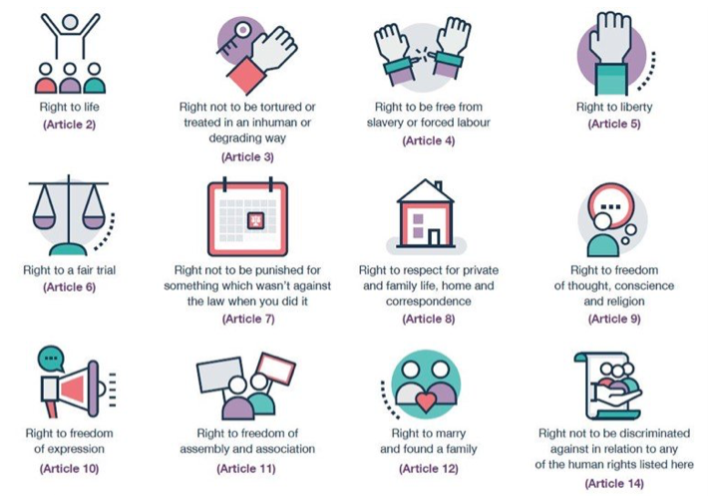
(some samples of important Human rights)

- Definition of Human Rights

Human Rights apply to all human beings from the moment they are born until they die. These rights are inherent to all humans regardless of gender, skin color, nationality, social status or sexual orientation. The Universal Declaration of Human Rights, which was implemented in 1948, is now the most translated document worldwide and has been signed by all 192 member states of the UN. The purpose of this declaration is to ensure a good and fair life for everybody or at least give them the opportunity to become the best version of themselves. In the image above, some of the most important human rights are depicted, such as the right to freedom or the right to protection against discrimination and/or torture.

- Article 26: Education

„Everyone has the right to education. Education shall be free, at least in the elementary and fundamental stages.[… ] higher education shall be equally accessible to all. Parents have a prior right to choose the kind of education that shall be given to their children.“ [declaration of human rights]

One of the major problems for children who are forced to fight for an armed group is that they are denied their human right to education. Children are often recruited in schools and when they are used as child soldiers, they can no longer attend school or get any form of education. If children are forced to leave school in the early stages of their lives, some even under the age of ten, they often aren’t able to read properly, which takes away any chances of further education. Child soldiers who aren’t provided with education are suffering under a severe violation of their human rights.
By taking away their chances for education they will suffer from lasting effects in the future. To elaborate, if these children survive the recruitment and fighting for armed forces but do not have any or just a very low level of education, they will not be able to attend higher education and or find work. They will struggle their entire lives with the consequences of having been denied education.
They won’t be able to read or think for themselves and they are more liable to further manipulation. If they are not taught basic facts at school, for example, what rights they have, what values they should maintain, they will often believe any information they get and will be more prone to ideological and radical ideas.
In conclusion, the increasing amount of child soldiers is a danger to children’s education and a clear violation of their human Rights.

- Article 25: Health

„Everyone has the right to a standard of living adequate for the health and well-being of himself and of his family, including food, clothing, housing and medical care and necessary social services“

Another human right that is violated when children are recruited as soldiers is the right to medical care. Whenever children are used as soldiers they are not able to get medical attention if they need it, and in severe cases they are not even provided with enough food to prevent malnutrition.
They are often forced to live under inhumane circumstances, e.g. in slums or simply on the street, in front of schools and hospitals they can’t afford. These children are lured away from their family, often with the promise of a better life, but in reality they suffer from gun inflicted injuries, sexual violence, hunger and diseases.
Sadly, many children still choose these promises over the life they live. That’s why it is important to understand that the general situation for children in affected countries needs to be improved so that the children join because of fear of poverty and / or hunger they are enduring do not feel the need to put their life in danger.
Still, it can’t be denied that regardless if the children had access to medical care, food and housing before, they do not have access to these as part of an armed group in most cases. To be clear, their situation is rather the opposite, instead of protecting children’s health these children are injured and sometimes even die.
In conclusion, article 25 of the Declaration of Human Rights is violated whenever children are used and recruited as child soldiers.
Of course, there are other human rights which are violated regarding this issue and need to be protected as effectively as possible by the Human Rights Council.

5. Lasting consequences for children who are recruited and used in armed Conflicts.
Children do not only suffer during the process of being recruited and used as child soldiers, many of them also have to cope with the lasting impacts on their lives. Besides educational disadvantages as explained before, there are many other negative consequences which can be divided into these two categories:

- Physical consequences
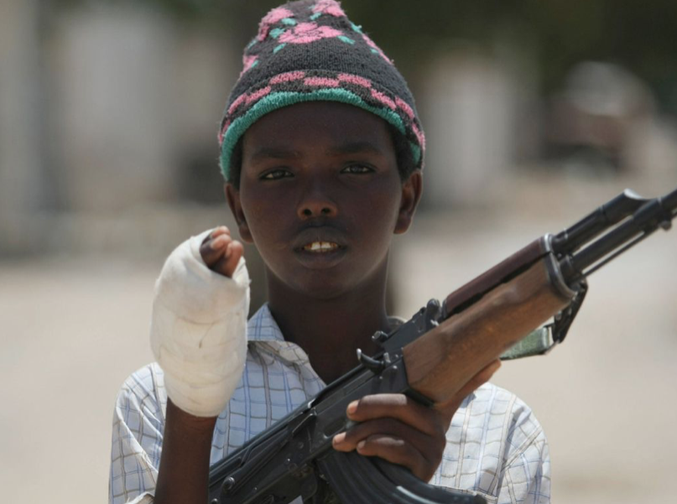
If the children aren’t killed in the process of fighting with guns and other military weapons, many of them will be physically injured. Some of them lose body parts while others are marked with scars or have lasting diseases due to chemical poisoning. In these cases, not only the process of being injured is very painful, but also the lack of medical treatment. When these children grow up they have to live with chronical pain for the rest of their lives or until they can get medical treatment.
These injuries prohibit them from having a future like everybody else. Children who were injured in wars and armed conflicts will have scars and harm, which, in many cases, prevents them from working and earning money. Their chance of a normal daily routine is already taken away at an early point in their lives.

- Psychological Consequences
When former child soldiers talk about what they experienced, it is obvious that all the violence, brainwashing and fear they felt must have lasting psychological consequences. These children grew up in an environment full of violence and had strangers tell them what is right and what is wrong. Being children they were vulnerable and could be influenced very easily.
Rape, sexual assault, violence, injuries and war itself are all things no one, not even children should experience. Many child soldiers have PTSD, anxieties, depression and sometimes even try to harm themselves because of their traumatic experiences. In other cases, children are brainwashed to believe in the ideological ideals they have to fight for.
Whatever traumatic experience they are part of, it is certain that they will have to deal with lasting consequences throughout their lives.

7.Steps against the Recruitment and Use of Child soldiers
Over the years there have been many governments and non-profit-organizations which have tried to fight against the recruitment of child soldiers. They have tried to help these children before, during and after their recruitment and use. Of course, their approaches are different:
- Approaches By Governments
There are many countries, for example Germany, Israel and the United States which fight against the recruitment of child soldiers.
The first method many governments implement / have implemented is informing children themselves about this issue through school and social media.
Additionally, many governments try to persuade non-state armed groups to sign contracts which forbid the use of children in armed conflict. This, for example, was the case in Columbia as mentioned before.
The UN focuses on the strategy of preventing wars/ armed conflicts, at best even before they start. They see this as the most efficient strategy because without violence and war no children are needed to become soldiers. Sadly, this strategy is very difficult to achieve because many civil groups cannot be controlled by the government.

- Approaches By NGOs ( Non-Profit-Organizations)
There are currently many NGOs which are fighting against the recruitment of child soldiers. But while this is a big concern, the majority of these NGOs are focused on helping former child soldiers to get back to a normal life.
They try to provide education, food, psychological / medical care and housing. Some of these organizations present more detailed information on their websites:
There was also a “Red hand day” implemented to raise awareness for child soldiers. On this day thousands of supporters against the use of child soldiers try to motivate people to donate for suffering children fighting in wars and armed conflicts. The Red Hand Day is on 12th February every year. The idea is to gather paintings of red hands all over the world to show the global effects of child soldiers and in how many countries there are reported cases. Furthermore, this organization tries to help former child soldiers through medical and psychological treatment. The main goal, however, remains to make aware of this global issue.

https://www.wri-irg.org/en
https://www.warchild.org
https://www.unicef.org
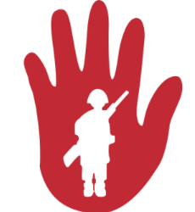
https://www.redhandday.org

Even with all the affords made by governments and non-profit-organizations the number of child soldiers is still increasing, especially in the Middle East and Africa. To this point, the UN is still searching for solutions to this pressing issue affecting thousands of children.

8.Useful links

- The official UN website always has serious, well-researched articles about this topic you can read to learn more:
https://www.un.org
- To get a short summary on your country’s opinion/ legal situation on this issue, you can visit the Wikipedia article about children in the military and skip to your country (not all countries can be found) :
https://en.wikipedia.org/wiki/Children_in_the_military

- For a more detailed overview on your country’s opinion of your country’s opinion on this issue you can visit:
https://www.refworld.org/publisher,CSCOAL,,,50ffbce591,,0.html
and read some articles published about your country’s opinion not all countries can be found) or use the “country information” function with the key word child soldiers on this side

- a summary of the topic can be found at:
https://www.unicef.org/chinese/protection/files/Armed_Groups.pdf

- This article also gives a good summery of the issue:
https://www.theguardian.com/global-development/2017/jul/24/south-sudan-child-soldiers

