United Nations Security Council
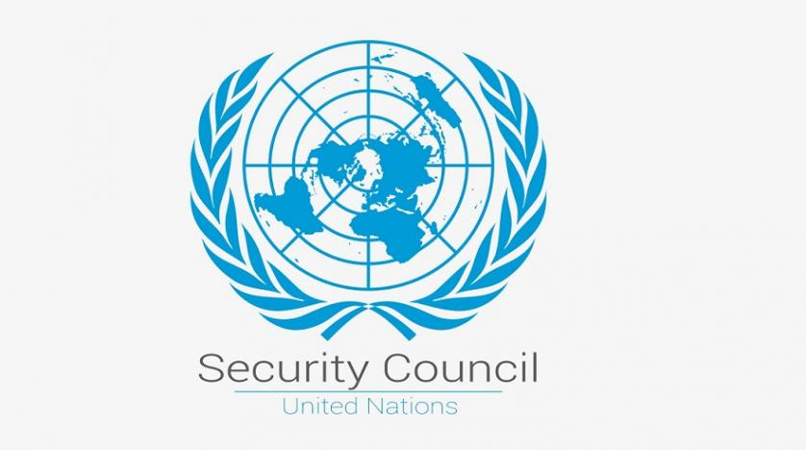

TOPIC 2: Measures to Prevent Further Violence and War Crimes during the Tigray War to Ensure the Safety of Ethiopian Citizens

Table of contents:
- The United Nations Security Council
- Introduction to the Topic
- Definition of Key Terms
- Timeline of Events
- Current Solutions
- Useful Links and Resolutions

- The United Nations Security Council
The United Nations Security Council, also UNSC or SC, which is one of the six organs of the United Nations, consists of ten members, which are elected on a regional basis to serve a term of two years, and five permanent members: the French Republic, the Russian Federation, the People´s Republic of China, the United Kingdom of Great Britain and Northern Island and the United States of America. These were the victors of World War II, which is why they can veto any substantive resolution, including those on the admission of new member states to the United Nations.
The Security Council has different tasks such as ensuring international peace and security, recommending the admission of new UN members and approving any changes to the UN Charter. Its powers include enacting international sanctions, establishing peacekeeping operations, authorizing military action and binding resolutions on member states.
The Security Council was created after World War II to maintain world peace. It authorized military interventions in the Korean War and the Congo Crisis and peacekeeping missions in the Suez Crisis, Cyrus, and West New Guinea. As of March 2019, there are thirteen peacekeeping missions with over 81,000 personnel from 121 countries, with a total budget of $ 6.7 billion.

- Introduction to the Topic
The Tigray War started on the 4th of November 2020 in the Region of Ethiopia, Africa´s oldest independent country, and is an ongoing conflict to this day. The Special Forces of the Tigray regional government are fighting the Ethiopian National Defense Force (ENDF), which are supported by the Ethiopian Federal Police and regional police with the help of the Eritrean Defence Forces (EDF). All parties involved, especially the ENDF and EDF, have committed war crimes during the conflict.
It all started in 2019 when Prime Minister Abiy Ahmed formed his new Prosperity Party and removed key Tigrayan government leaders with the goal to distance the country from ethnic nationalism and federalism. This new party consists of the Ethiopian People´s Revolutionary Democratic Front (EPRDF) coalition and several opposition parties. The entity the Tigray People´s Liberation Front (TPLF), refused to join this new party. Abiy Ahmed took it further when he postponed the general elections to 2021 due to the ongoing COVID-19 pandemic. The TPLF went ahead with regional elections in Tigray in defiance of the federal government. This federal government then declared the Tigray election illegal. Journalists were barred by the federal government from traveling to cover Tigray's regional election. Finally, the central government suspended funding for Tigray, which was seen as the “Declaration“ of war.
The actual fight began with the November attacks on Northern Command bases and headquarters of the ENDF in Tigray region by TPLF-aligned security forces, which was described as a police action. The TPLF stated that the fighting would continue until the” Invaders“ are out.
The war has already taken at least 10,000 lives. War rape has become a daily occurrence for many girls and women from the age of 8 to 72. Hundreds of women reported rapes and sexual assault. Furthermore, putting women in danger of diseases, injuries and unwanted pregnancies has devastated families and entire communities. The need for authorities to take action remains urgent. Mass extrajudicial killings of civilians took place. Almost 2,000 people were killed in massacres by soldiers. The victims were between the age of 92 and infants, as the youngest. Researchers found out that only 3% of identified victims had been killed in air strikes; most of them had been shot to death in organised massacres or during searches. A lot is still unknown, many victims have not even been identified yet. There has been limited access to clean water and about 4.5 million people are still in need of aid, about 1 million of these are not in accessible areas due to ongoing fighting. All the routes into Tigray have been blocked, except one for food convoys, which has recently been attacked.
Several peace and mediation on proposals by former African presidents, East African heads of government, the National Congress of Great Tigray, the Tigray Independence Party and the Salsay Weyane Tigray have been proposed.
Opponents of the TPLF have described this development as a heavily armed ethnic nationalist paramilitary insurgency, terrorist organization, political party and former ruling authoritarian regime of Ethiopia. The day before the TPLF's attacks, the federal parliament of Ethiopia had suggested to designate the TPLF as a terrorist organisation.
The whole conflict does not only evoke a humanitarian crisis but also an economical one as Ethiopia is a significant economical partner for its neighbouring states. Therefore, it is our essential task to ensure the safety of all Ethiopian citizens in terms of famine, oppression and workplace. Experts say that the collapse of the state is a real possibility because there are no signs of abating at all. The Tigray War has also increased fears of a wider crisis with the potential to tear apart the whole country as well as neighbouring countries, which could affect the entire Horn of Africa.
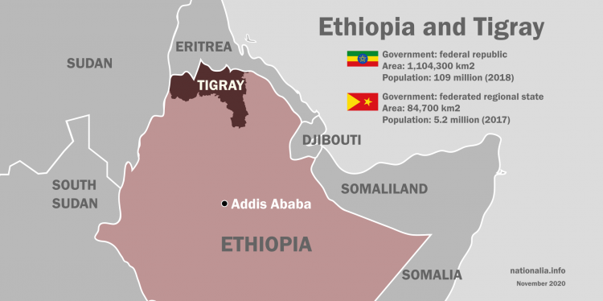

- Definition of key terms
Tigray: Tigray is one of the 10 regional states of Ethiopia and is located in the north of Ethiopia. This is the place where most of the war crimes take place, whereas some are spilling over into Afar (neighbouring region) or even into Sudan or Somalia.
Civil war: When citizens of the same country fight against each other in a war, that war is called a civil war.
Humanitarian crisis: A humanitarian crisis is defined as a danger for health, security or well-being of a large group or community with its roots in one or several incidents.
Human Rights: Human Rights apply to all human beings from the moment they are born until they die. These rights are inherent to all humans regardless of gender, skin color, nationality, social status, or sexual orientation. The purpose of the Human Rights is to ensure a good and fair life for everybody or at least give them the opportunity to become the best version of themselves.
Refugee: A refugee is a person who has been forced to leave his/her country in order to escape war, persecution, or disaster. Many refugees flee to more industrial countries to build a better life there.
Joint Investigation Team: A Joint Investigation Team – also JIT – is a set up investigation team for a limited time period with the participation of authorities from at least two EU member states. Regarding the conflict in Tigray, a JIT has been established.
War crime: An act carried out during the conduct of a war that violates accepted international rules of war is called a war crime.

- Timeline of events
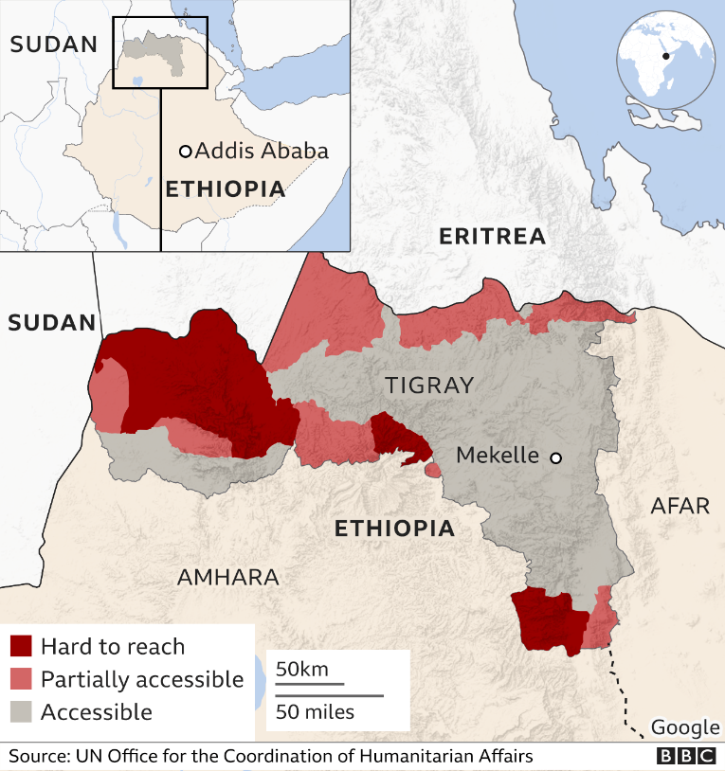
The more you get into the topic, the more you realize how complex this conflict is. It is not only a war between Ethiopia and Tigray but also between Eritrea and Tigray as the TPLF ruled Ethiopia during the Eritrean-Ethiopian border war at the end of the 20th century and because of the fact that Eritrea’s leader, Isaias Afwerki, is a sworn enemy of the TPLF.
Additionally, it is very hard to reach the Tigray region and its citizens as most of the routes have been restricted. All flights are required to land first in Addis Ababa, the capital of Ethiopia for inspection. For instance, in July only one convoy was able to reach the Tigray region although this represents just 1% of the food supply that is needed for the whole month - according to Samantha Power of the US agency for International Development (USAID). The restrictions are mainly enforced by the Ethiopian government, not by the TPLF. A spokesperson for the Ethiopian prime minister justifies these restrictions and multiple checks as a measure “to equally ensure and guarantee security”.
The situation in Ethiopia has not improved; from time to time, it actually gets worse. In August 2021, Abiy Ahmed called for civilians to join the war making it much more difficult to stop the conflict because the more protracted it becomes, the harder it will be to contain. Additionally, the neighbouring regions Afar and Amhara were pulled in after primarily geographically eight months of war within the Tigray region. Well, the conflict is threatening to escalate as another party joined it: The Oromo Liberation Army, an armed group from southern Ethiopia, has announced they are working with the TPLF. Forecasting, the whole horn of Africa may get destabilized by the Tigray war.

- Current solutions
Since this has been an ongoing war for nearly a year, no explicit war-ending solution has been found yet. However, the United Nations are aware of the dramatic situation in Ethiopia. Therefore, not only the Security Council but also the United Nations Human Rights Council is currently debating on that topic in order to find suitable solutions that will stop the civil war and the humanitarian crisis in Tigray.
There are already some resolutions that talk about the situation in Tigray, which is fine but not sufficient. A political upheaval in Ethiopia is necessary. On that account, the most important measure that has to be taken is ensuring the safety, well-being and health of all Ethiopian citizens that are negatively influenced by the Tigray war. Hence, an official, legit dialogue between the federal government of Ethiopia and the Tigrayan leadership is needed more than ever. Authorities should swiftly accede to international demands – echoed by Tigray interim officials – for complete access to offer life-saving assistance. Donors, and particularly the African Union’s trio of peace envoys, should press this message home. Following the EU’s lead, others should unite to insist that humanitarian agencies get full access to all of Tigray, via a deal with Tigrayan forces if necessary.
In addition, a withdrawal by the Ethiopian National Defence Forces (ENDF) and the Ethiopian Federal Police and regional police, as well as the Eritrean Defence Forces (EDF) should be expected.

- Useful links:
- Tigray assault on Ethiopia's Afar causes heavy casualties, displacement (trtworld.com)
- Thousands killed in Ethiopia’s conflict, Tigray side asserts | PBS NewsHour
- A War Fought in the Dark - A Brief Overview of the War on Tigray - Omna Tigray
- Ethiopia’s Tigray war: The short, medium and long story - BBC News
- Finding a Path to Peace in Ethiopia’s Tigray Region | Crisis Group
- Ethiopia: Fear Tigray conflict could trigger all-out war | Africa | DW | 20.07.2021
- United Nations | Peace, dignity and equality <BR>on a healthy planet
- Home | Amnesty International
- Escalating Tigray conflict poses threat to whole East African region | DW News - YouTube
- How far will Ethiopia's PM go to fight rebels in Tigray? | Inside Story - YouTube
Resolutions:
- A/HRC/47/L.20/Rev.1 - E - A/HRC/47/L.20/Rev.1 -Desktop (undocs.org)
- BILLS-117sres97ats.pdf (congress.gov)
- United Nations Digital Library System (here you can search for all documents published by the UN – including resolutions)

