**United Nations Security Council**

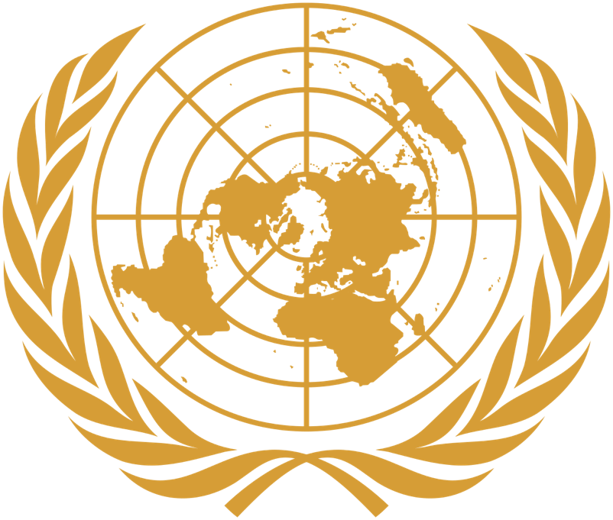

**TOPIC 2: Measures to Stop the Ongoing Terrorism in Afghanistan with Special Regards to the Taliban and their Allies as well as State Sponsors of Terrorism**

Table of Contents

1 Introduction to the Topic…………………………………………………2

* 1. The Taliban…………………………………………………………...2
  2. The Haqqani Network……………………………………………….3
  3. Al-Qu’aida…………………………………………………………….4
  4. State Sponsors……………………………………………………….5

1. Past Actions……………………………………………………………..5
2. Useful Links……………………………………………………………..6

Introduction to the topic

* 1. **The Taliban**

The Taliban, a Sunni Islamist nationalist movement with a pro-Pashtun ideology, emerged in the early 1990s. Their name, "Taliban," translates to "students" in Pashto. Initially composed of peasant farmers and students from Afghan and Pakistani madrasas (religious schools), the Taliban militarily gained control over most of Afghanistan from 1996 until October 2001. The group found initial support and strength in southern Afghanistan.

By 1994, the Taliban had advanced through the southern provinces, seizing territory from various factions engaged in a civil war that followed the collapse of the Soviet-backed Afghan government in 1992. By September 1996, they had captured Kabul, executed the president, and established the Islamic Emirate of Afghanistan, enforcing a strict interpretation of Islamic law. This regime was notorious for its harsh policies towards women, political opponents, and religious minorities.

In the years preceding the 11 September 2001 attacks in the United States, the Taliban provided sanctuary to al-Qa‘ida, enabling the terrorist group to recruit, train, and operate with relative freedom. The Taliban's control over Afghanistan persisted until October 2001, when they were ousted by a US-led military campaign targeting al-Qa‘ida.

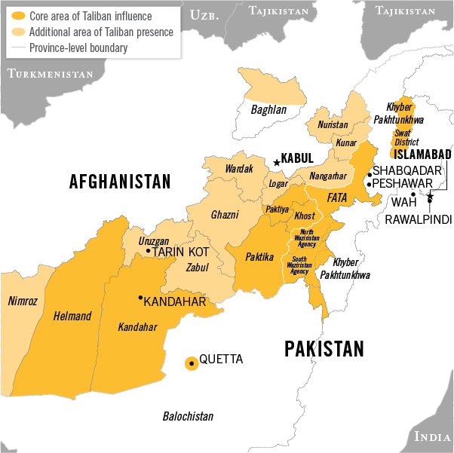One of the most pivotal developments in the region occurred in July 2015, when the Taliban announced the death of their elusive leader, Mullah Mohammed Omar, who had actually died in 2013. Omar, the head of state during the Taliban's rule and a key supporter of Usama Bin Ladin, was a wanted figure by the US government. Following Omar's death, Mullah Akhtar Mohammed Mansur, his deputy, was appointed as the new leader in August 2015, becoming only the second leader in the Taliban’s history. The Taliban remain the primary force behind insurgent activities in Afghanistan, characterized by regular low-level ambushes and hit-and-run attacks, as well as occasional high-profile assaults. Their activities have intensified, with suicide and complex attacks rising by 78% in the first half of 2015 compared to the same period in 2014. A series of attacks between 7 and 10 August 2015 in Kabul resulted in at least 60 deaths, marking one of the deadliest periods in the capital since the 2001 US-led invasion. These included a massive truck bomb explosion, a suicide bombing at Kabul Police Academy, and an assault on Camp Integrity, a NATO facility.

**1.2 The Haqqani Network**

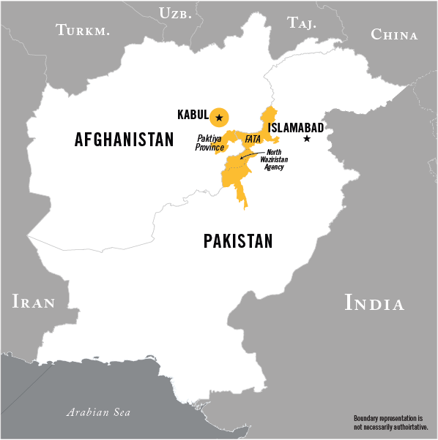The Haqqani Network, a Sunni Islamist militant group, was founded by Jalaluddin Haqqani, a prominent Afghan warlord and insurgent commander during the anti-Soviet war. Initially a member of the Hezb-e Islami faction led by Younis Khalis, Jalaluddin later allied with the Afghan Taliban, serving as the Minister of Tribal and Border Affairs during the Taliban's rule in the mid-to-late 1990s. He was closely associated with Usama Bin Ladin, acting as one of his key mentors during the 1980s Afghan war. Currently, the day-to-day operations of the Haqqani Network are led by Jalaluddin's son, Sirajuddin Haqqani. In August 2015, Sirajuddin was named a deputy to the newly appointed Taliban leader, Mullah Akhtar Mohammed Mansur, strengthening the alliance between the Haqqanis and the Taliban.

Primarily based in North Waziristan, Pakistan, the Haqqani Network conducts cross-border operations into eastern Afghanistan and Kabul. The group, mainly composed of members of the Zadran tribe, is regarded as the most lethal and sophisticated insurgent group targeting US, Coalition, and Afghan forces. Their tactics include coordinated small-arms assaults, rocket attacks, IEDs, suicide bombings, and attacks using bomb-laden vehicles.

The Haqqani Network has orchestrated some of the highest-profile attacks in the Afghan conflict. These include the June 2011 assault on the Kabul Intercontinental Hotel, carried out jointly with the Afghan Taliban, and major suicide bombings against the Indian Embassy in Kabul in 2008 and 2009. In September 2011, the Haqqanis were involved in a day-long assault on major targets in Kabul, including the US Embassy, ISAF headquarters, the Afghan Presidential Palace, and the Afghan National Directorate of Security headquarters. In October 2013, Afghan security forces intercepted a truck bomb deployed by the Haqqanis against Forward Operating Base Goode in Paktiya Province. This device, containing 61,500 pounds of explosives, was the largest truck bomb ever built. The Haqqani Network is also engaged in various criminal activities in Afghanistan and Pakistan, such as extortion, kidnapping for ransom, and smuggling.

After decades of conflict and a high level of poverty, the Taliban increasingly took over parts of the country and in August 2021 the capital Kabul. The Americans and their allies immediately withdrew all forces from the country.ß This resulted in an even faster economic decline, increasing food insecurity and widespread deprivation.

At the same time, the Taliban's actions and decisions contrary to their commitments, have led to the dramatic worsening of the political, economic, humanitarian and human rights situation for the Afghan people, especially for women and girls.

* 1. **Al-Qa’ida**

Al-Qa‘ida was established in 1988 by Usama Bin Ladin, uniting Arab fighters from the Soviet-Afghan war. The organization’s primary objective is to create a pan-Islamic caliphate, aiming to unify Muslims against Western powers, particularly the United States. Al-Qa‘ida strives to overthrow what it considers "apostate" Muslim regimes, expel Western influence from Muslim-majority countries, and defeat Israel. In February 1998, under the banner of "the World Islamic Front for Jihad Against the Jews and Crusaders," al-Qa‘ida proclaimed it a duty for all Muslims to kill US citizens—both civilian and military—and their allies worldwide.

Al-Qa‘ida has carried out several high-profile attacks. On September 11, 2001, nineteen al-Qa‘ida operatives hijacked four US commercial airplanes, crashing them into the World Trade Center in New York City, the Pentagon near Washington, D.C., and a field in Shanksville, Pennsylvania, resulting in nearly 3,000 deaths. On October 12, 2000, an al-Qa‘ida attack on the USS Cole in Aden, Yemen, killed 17 US sailors and injured 39 others. On August 7, 1998, al-Qa‘ida bombed the US embassies in Nairobi, Kenya, and Dar es Salaam, Tanzania, killing 224 people and injuring over 5,000. In 2005, Ayman al-Zawahiri, then Bin Ladin’s deputy, claimed responsibility for the 7/7 bus bombings in the UK. In 2006, British authorities thwarted an al-Qa‘ida plot to bomb multiple transatlantic flights departing from London’s Heathrow airport.

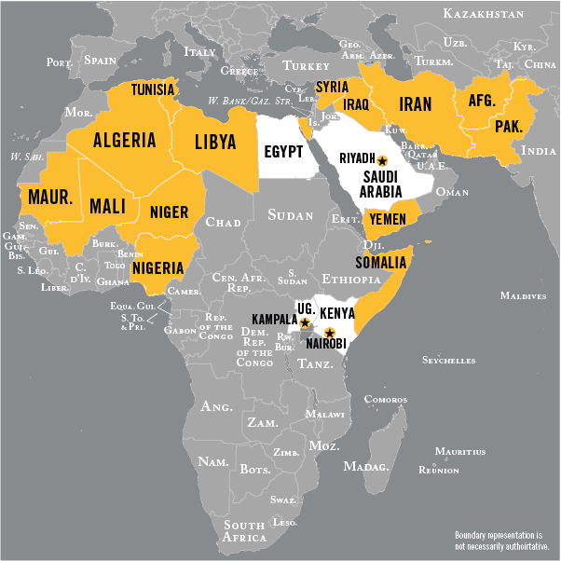Following Bin Ladin’s death in 2011, al-Zawahiri was named his successor. While al-Zawahiri leads a small but influential cadre of senior leaders known as al-Qa‘ida Core, the group's cohesiveness has diminished in recent years due to counterterrorism efforts and the rise of other organizations like the Islamic State of Iraq and the Levant (ISIL). Leadership losses, such as the deaths of Nasir al-Wahishi and Abu Khalil al-Sudani in 2015, have further weakened the organization's core functions. Nevertheless, al-Qa‘ida and its affiliates in South Asia, Africa, and the Middle East remain resilient and committed to conducting attacks against the United States and its interests abroad. Despite counterterrorism pressures, al-Qa‘ida continues to plan and attempt attacks, underscoring its enduring threat.

* 1. **State Sponsors**

State Sponsors of Terrorism" is a designation applied to countries that are alleged to have "repeatedly provided support for acts of international terrorism" per the United States Department of State. This support can take various forms, such as funding terrorist organizations, providing training, supplying weapons, offering logistical and intelligence assistance, and allowing groups to operate within their borders.

As of 2024 the list of state sponsors consists of Cuba (since 2021), Iran (since 1984), the Democratic People’s Republic of Korea (since 2017) and Syria (since 1979).

In May 2022, Senators Richard Blumenthal and Lindsey Graham announced the introduction of the resolution calling on the Biden administration to designate Russia as a state sponsor of terrorism for its war on Ukraine.

Iran has had a complex relationship with the Taliban, shifting from adversarial to more cooperative interactions over time. Reports indicate that Iran has provided the Taliban with weapons, training, and funding, particularly in their fight against U.S. and NATO forces. Iran's support is seen as a strategic move to counter U.S. influence in the region.

While not traditionally listed as a state sponsor of terrorism, Russia has been accused of providing support to the Taliban in recent years. This support reportedly includes arms and possibly financial assistance. The motivations behind Russia's involvement are believed to include undermining U.S. efforts in Afghanistan and maintaining influence in Central Asia.

2. Past Actions

In January 2015, NATO launched the Resolute Support Mission (RSM) to train, advise and assist Afghan security forces and institutions to fight terrorism and secure their country. Following the completion of the withdrawal of all RSM forces in August 2021, the Mission was terminated in early September 2021. Under the current circumstances, NATO has suspended all support to Afghanistan. Any future Afghan government must adhere to Afghanistan’s international obligations; safeguard the human rights of all Afghans, particularly women, children and minorities; uphold the rule of law; allow unhindered humanitarian access; and ensure that Afghanistan never again serves as a safe haven for terrorists.

The European Union enforces sanctions against those who pose a threat to the peace, stability, and security of Afghanistan, targeting the Taliban and associated individuals and groups. These sanctions are in accordance with UN Security Council Resolution 1988 (2011) and include several measures:

1. An arms embargo
2. A ban on technical assistance related to military goods and technology
3. Travel bans for specific individuals
4. An asset freeze for designated individuals and entities
5. Currently, this sanctions regime affects 135 individuals and 5 entities, aiming to curb the influence and operations of terrorist groups in Afghanistan.

A wide range of sanctions are imposed as a result of a State Sponsor of Terrorism designation, including:

1. A ban on arms-related exports and sales
2. Controls over exports of dual-use items, requiring 30-day Congressional notification for goods or services that could significantly enhance the terrorist-list country’s military capability or ability to support terrorism
3. Prohibitions on economic assistance
4. Imposition of miscellaneous financial and other restrictions

3. Useful Links

<https://www.un.org/securitycouncil/>

<https://www.dni.gov/nctc/index.html>

<https://www.nato.int/cps/en/natohq/topics_8189.htm>

<https://press.un.org/en>

<https://www.nato.int/cps/en/natohq/topics_77646.htm>