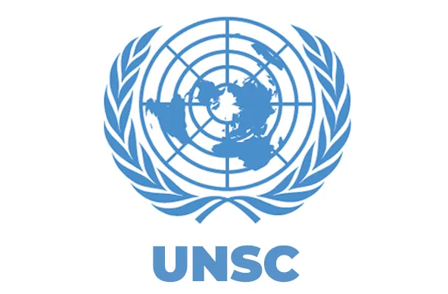
The United Nations Security Council

Measures to Ensure Peace Stability and Security amid the ongoing Conflict in Sudan
-Committee Guide-

Julia Behrens
-Chairperson-
Kaleb Ancheta
-Chairperson-
Enie Burkert
-Chairperson-
Felix Knoll
-Chairperson-

CONTENTS

- Introduction
- Indroduction to the committee
- Introduction to the topic
- Backgrounds: Facts and Numbers
- Current Situation
- The major parties involved
- Definition of key terms
- Past International actions
- Possible Solution
- Guiding Questions for the debate
- Useful links
- Sources

I.Introduction

- Indroduction to the committee

The United Nations Security Council (UNSC) is one of the six principal organs of the United Nations and bears the primary responsibility for the maintenance of international peace and security. Established in 1945 under the UN Charter, the Council serves as the international community's foremost body for addressing threats to peace, acts of aggression, armed conflicts, and other issues that may endanger global stability.

The Security Council consists of fifteen member states: five permanent members: China, France, the Russian Federation, the United Kingdom, and the United States; and ten non-permanent members elected by the United Nations General Assembly for two-year terms. The permanent members possess veto power, enabling them to block the adoption of substantive resolutions.

Unlike most other UN bodies, the Security Council has the authority to adopt legally binding resolutions. Its powers include authorizing peacekeeping operations, imposing sanctions, establishing international tribunals, and, when necessary, approving the use of force to restore international peace and security. Through these mechanisms, the Council plays a central role in responding to global challenges.

In this committee, delegates will be expected to represent the interests and policies of their assigned countries while working collaboratively to address complex international security issues. Success in the Security Council requires strong diplomacy, negotiation skills, strategic thinking, and a thorough understanding of both national interests and international law.

- Introduction to the topic

Since April 2023, Sudan has been engulfed in a devastating armed conflict
between the Sudanese Armed Forces (SAF) and the paramilitary Rapid Support
Forces (RSF). What initially emerged as a power struggle between rival military
factions has evolved into one of the most severe humanitarian and security
crises of the twenty-first century. The conflict has claimed tens of thousands of
lives, triggered widespread and systematic human rights violations, devastated
critical infrastructure, and displaced millions of civilians both within Sudan and
across its borders.

The ongoing violence has not only undermined Sudan’s internal stability but has
also generated significant regional security challenges. Large-scale refugee
movements, the proliferation of weapons, growing food insecurity, and the risk of
further regional spillover threaten peace and stability throughout the Horn of
Africa and beyond. Moreover, Sudan remains highly vulnerable to natural
disasters and the adverse effects of climate change. Recurring droughts, severe
flooding, desertification, and increasing water scarcity have exacerbated existing
socio-economic vulnerabilities, undermined agricultural productivity, and
intensified competition over limited natural resources.

In conjunction with the
armed conflict, these factors have further deteriorated humanitarian conditions
and complicated both emergency relief operations and long-term peacebuilding
efforts. Consequently, international actors, including the United Nations, the
African Union, and the Intergovernmental Authority on Development (IGAD), have
repeatedly called for an immediate cessation of hostilities and a comprehensive
political settlement.

As the situation continues to deteriorate, the United Nations Security Council
faces the critical task of identifying and implementing effective measures to
promote peace, protect civilians, ensure unhindered humanitarian access, and
facilitate a sustainable political transition. Addressing the conflict in Sudan is not
only essential for safeguarding the well-being and fundamental rights of its
population but also for preserving regional stability and maintaining international
peace and security.

II. Backgrounds: Facts and numbers

• Conflict outbreak: 15 April 2023
• Estimated death toll: More than 150.000 people are estimated to have died
as a result of the conflict
• Internally displaced persons (IDPs): More than 10 million
• Refugees in neighboring countries: More than 4 million
• People in need of humanitarian assistance: Approxiamately 30 million• People facing acute food insecurity: more than 25 million
• Children in need of humanitarian assistance: approximately 16 million
• Countries most affected by refugee flows: Chad, South Sudan, Egypt,
Ethiopia and the Central African Republic
• Main conflict parties: Sudanese Armed Forces (SAF) and Rapid Support
Forces (RSF)
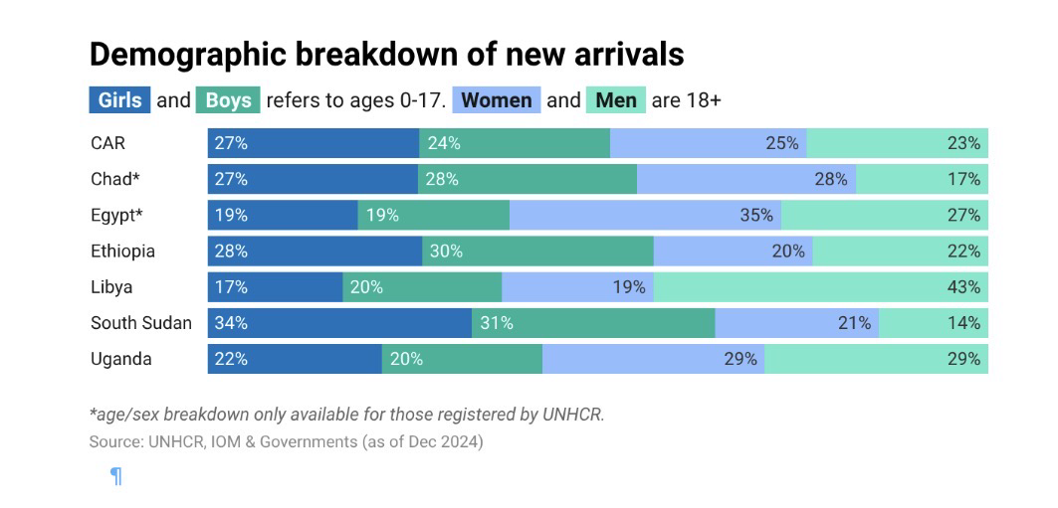
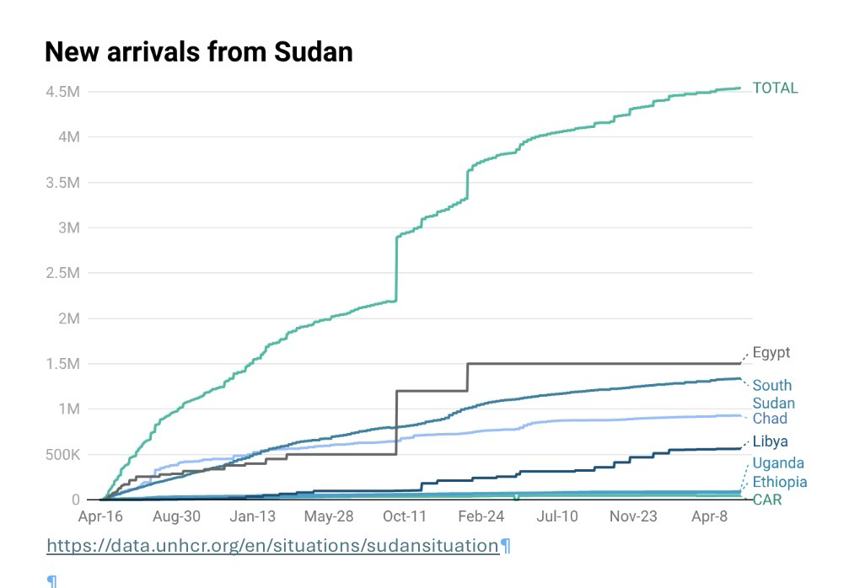

III.Current Situation

Since April 2023, Sudan has been facing a new civil war involving the Sudanese
Armed Forces (SAF) and the Rapid Support Forces (RSF). The war has exacerbated
the already critical humanitarian crisis and caused acute food insecurity. In addition,
there are reports of widespread human rights abuse. They include attacks against
civilians based on their alleged affiliation or ethnicity, sexual and gender-based
violence, targeted attacks on healthcare facilities, and the energy infrastructure and
the recruitment and the use of children in armed conflicts. Sudan has also been
facing extreme weather events, such as floods and droughts. According to the United
Nations, over 33.7 million people are in need of urgent humanitarian assistance.
According to UNICEF, more than 8.4 million children are out of school, and the
majority of Sudan's population lacks access to essential healthcare. Two out of five
Sudanese are facing acute food insecurity, which equals around 45% of the
Sudanese population. Currently, Sudan is facing the largest displacement crisis in
the world, with 9 million displaced internally and more than 4.4 million who have fled
outside of the country, mostly to neighboring countries. Sudan currently has no
stable government due to the ongoing conflict. The country is effectively divided
between areas controlled by the Sudanese Armed Forces (SAF), led by General
Abdel Fattah al-Burhan, and those controlled by the Rapid Support Forces (RSF).

Internationally, Sudan is still represented by institutions aligned with the SAF, which
continue to hold the country’s seat at the United Nations and are treated as the
official state authority. The RSF is not recognized as a governing authority. Efforts by
the United Nations and regional actors to support a political settlement have so far
not led to a lasting agreement.

The United Nations have shown efforts to stop the ongoing violence and supply the
Sudanese population with the needed goods. Unfortunately, ongoing attacks on
civilian infrastructure and settlements have severely impeded the UN's presence and
humanitarian operations in crisis-affected areas.

IV. The major parties involved

Sudanese Armed Forces (SAF):

The Sudanese Armed Forces (SAF) make up the national military of Sudan and are
responsible for the country's defense and security. As the state's official armed forces,
the SAF have played a central role in Sudan's political and security affairs.
The SAF are led by General Abdel Fattah al-Burhan, who also is the Chairman of
Sudan's Transitional Sovereignty Council. After the removal of President Omar al-Bashir
in 2019, the SAF became a key factor in the country's transitional process.
Since the outbreak of hostilities, in connection to the Conflict erupted in April 2023, the
SAF have carried out military operations in several regions of the country with the stated
objective of restoring state authority and national security.
The SAF have also been included in allegations of violations of international
humanitarian law and international human rights law. Reports by the United Nations
and other international organizations have documented allegations of attacks affecting
civilians and civilian infrastructure and concerns regarding the protection of civilians
during military operations. Investigations into alleged violations remain ongoing.

Rapid Support Forces (RAF):

The Rapid Support Forces are a paramilitary force operating in Sudan. Established in
2013, the RSF emerged from militia groups that had previously been active in the
Darfur region. Over time, the force expanded its military, political, and economic
influence across the country.
The RSF is led by Mohamed Hamdan Dagalo and played a significant role in Sudan's
political transition including the removal of President Omar al-Bashir in 2019.
However, disagreements regarding the integration of the RSF into the Sudanese
Armed Forces (SAF) contributed to rising tensions between the two parties. These
tensions culminated in the outbreak of armed conflict in April 2023.
Since the onset of the conflict, the RSF has been included in many allegations of
violations of international humanitarian law and international human rights law.Reports by the United Nations and other international organizations have
documented allegations of attacks against civilians, conflict-related sexual violence,
forced displacement, and ethnically motivated violence. Investigations and
accountability efforts remain ongoing.

The United States:

The United States has consistently called for an immediate ceasefire, the protection
of civilians, and unrestricted humanitarian access throughout Sudan. It supports a
return to a civilian-led democratic transition and has condemned violations of
international humanitarian law committed by both the Sudanese Armed Forces (SAF)
and the Rapid Support Forces (RSF). The U.S. has imposed targeted sanctions on
individuals and entities associated with both parties to the conflict and advocates for
greater international accountability for human rights abuses. Washington also
provides significant humanitarian assistance to Sudan and neighboring countries
hosting refugees.

The United Kingdom:

The United Kingdom strongly supports UN-led diplomatic efforts to end the conflict
and restore a civilian-led government. It has repeatedly emphasized the need to
protect civilians, ensure humanitarian access, and uphold international humanitarian
law. The UK has introduced targeted sanctions against individuals and organizations
linked to the conflict and works closely with international partners to coordinate
humanitarian aid and diplomatic initiatives.

France:

France advocates for an immediate cessation of hostilities and supports mediation
efforts led by the United Nations, the African Union, and regional organizations. It
emphasizes the protection of civilians, respect for international law, and unrestricted
humanitarian access. France also supports a civilian political transition and has
contributed to international humanitarian assistance for Sudan and neighboring
countries affected by the refugee crisis.

Russia:

Russia calls for an immediate ceasefire and a negotiated political settlement while
emphasizing the principles of state sovereignty and non-interference in Sudan's
internal affairs. Moscow maintains diplomatic contacts with both the SAF and the
RSF and generally opposes external measures that could be seen as interfering in
Sudan's domestic affairs, including broad sanctions imposed without the consent of
the Sudanese authorities. Russia has therefore favored dialogue over coercive
measures within the UN Security Council

China:

China supports an immediate ceasefire, humanitarian assistance, and dialogue
between the conflicting parties. At the same time, it consistently emphasizes respect
for Sudan's sovereignty, territorial integrity, and political independence. China
generally opposes external intervention and supports African-led solutions to the
conflict. Maintaining long-standing economic and political relations with Sudan, China
continues to engage with the internationally recognized Sudanese state institutions
while encouraging a peaceful political resolution

V. Definition of key terms

Armed Conflict:
A situation where organized groups use violence against each other, usually involving military forces.
Ceasefire:
An agreement between conflict parties to temporarily or permanently stop fighting.
Humanitarian Crisis:
A situation where large numbers of people suffer from lack of food, shelter, healthcare, and safety.
Internally Displaced Persons (IDPs):
People who are forced to flee their homes but remain within their own country.
Refugees:
People who flee their country to escape war, violence, or persecution.
Humanitarian Access:
The ability of aid organizations to reach people in need and deliver help.
Sanctions:
Measures (often economic or political) used by countries or the UN to pressure actors to change behavior.
Sovereignty:
The principle that a country has control over its own territory and internal affairs without outside interference.

VI. Past International actions

Previous international efforts to resolve the conflict in Sudan have mainly focused on diplomatic negotiations, targeted economic sanctions, and the documentation of human rights violations. However, these measures have largely been ineffective due to the unwillingness of the military leaders to compromise.
The most important diplomatic initiative has been the Jeddah Process, led by the United States and Saudi Arabia. In May 2023, the Sudanese Armed Forces (SAF) and the paramilitary Rapid Support Forces (RSF) signed the Jeddah Declaration, committing to the protection of civilians and the delivery of humanitarian aid. However, both sides quickly violated the agreed ceasefires, causing the talks to stall.
At the same time, regional organizations such as the African Union (AU) and the Intergovernmental Authority on Development (IGAD) attempted to find political solutions. The AU supported an inclusive dialogue within Sudan that would involve civilian actors and prevent long-term military rule. Meanwhile, IGAD tried to bring the two opposing leaders, General Abdel Fattah al-Burhan and General Mohamed Hamdan Dagalo (Hemedti), into direct negotiations.
As diplomacy failed to achieve results, Western countries increased economic pressure. The United States and the European Union imposed sanctions on key companies and financial networks linked to both sides. These measures targeted, in particular, gold mining companies connected to the RSF and state-owned arms companies linked to the SAF. However, both parties were often able to bypass these sanctions through informal networks and allied states, limiting their effectiveness.
On the legal and humanitarian level, the United Nations became involved. The UN Human Rights Council established an independent fact-finding mission to document war crimes, ethnic cleansing, and sexual violence for future prosecution. In addition, the UN Security Council called for a ceasefire and the lifting of sieges on major cities in several resolution
.
The limited success of these efforts can largely be explained by the lack of coordination in international diplomacy. Different initiatives by the United States, African actors, and regional powers often took place separately, allowing the Sudanese leaders to delay negotiations and continue pursuing a military solution.

VII. Possible Solutions
Achieving long-term stability in Sudan requires a coordinated approach based on five key pillars:

1. Strengthening International Mediation
International mediation efforts need better coordination to avoid parallel and ineffective negotiations. Diplomatic initiatives can be brought together under one framework, for example led by the African Union (AU) in cooperation with the United Nations, the European Union, and the Arab League. Confidential back-channel diplomacy can also help reduce tensions and allow leaders to negotiate more openly. In addition, it is important to include civilian actors such as civil society groups, youth organizations, and trade unions to ensure a more inclusive and lasting peace process.

2. Limiting External Military and Financial Support
External support has helped prolong the conflict. Therefore, stronger international pressure on third-party states is necessary to stop the supply of weapons and funding. A strictly enforced global arms embargo could further limit the ability of the conflict parties to continue fighting.

3. Protecting Civilians and Ensuring Humanitarian Access
Protecting civilians must be a top priority. This includes creating safe humanitarian corridors and demilitarized zones in conflict areas. International support should focus on strengthening local aid organizations to ensure that help reaches the population directly.
Special protection and support should be provided for vulnerable groups, especially survivors of gender-based violence.

4. Ensuring Legal Accountability and Transitional Justice
Long-term peace requires accountability for crimes committed during the conflict. This includes documenting and investigating war crimes and human rights violations.
After the conflict, mechanisms such as truth and reconciliation commissions can help address past injustices and support reconciliation.

5. Linking Security with Economic Development
Stability also depends on economic development. Supporting local conflict resolution and strengthening community leadership can help prevent further violence.
At the same time, creating economic opportunities, such as rebuilding infrastructure and offering training programs, can reduce dependence on war-related income and support long-term stability.
VIII. Guiding Questions for the debate

1. How can the UN Security Council effectively enforce a ceasefire in Sudan?
2. Should external military intervention be allowed, or should Sudan’s sovereignty be prioritized?
3. How can humanitarian aid be delivered safely despite ongoing violence?
4. What role should neighboring countries play in resolving the conflict?
5. Are sanctions effective in this conflict, or do they worsen the humanitarian situation?
6. How can civilians, especially vulnerable groups, be better protected?
7. What can be done to stop the flow of weapons into Sudan?
8. How can long-term political stability and a civilian government be achieved?
9. What mechanisms can ensure accountability for war crimes and human rights violations?
10. How can international actors better coordinate their efforts to avoid ineffective parallel initiatives?

IX. Useful links

- https://www.un.org/en/spotlight-on-sudan?utm
general overview
- https://news.un.org/en/focus/sudan-conflict?utm
- Current updates
- https://www.securitycouncilreport.org/sudan/?utm
- Country positions
- https://www.securitycouncilreport.org/un_documents_type/security-council-resolutions/?ctype=Sudan&utm
- Past actions
- https://www.undp.org/sudan/peace-and-stabilization?utm
- Solutions / development
- https://www.brookings.edu/articles/ending-sudans-civil-war-a-roadmap-to-peace-and-reconciliation/?
- Deeper analysis
- https://www.amnesty.org/en/location/africa/east-africa-the-horn-and-great-lakes-region/sudan/?utm
- Human rights
- https://www.hrw.org/africa/sudan?utm
- War crimes reports

X.Sources
- https://newlinesinstitute.org/global-security-mil-priorities/the-case-for-u-s-involvement-in-the-sudanese-civil-war/
- https://www.undp.org/sudan/peace-and-stabilization
- https://www.dabangasudan.org/en/all-news/article/sudan-timeline-october-december-2025-a-collective-failure-to-end-a-brutal-war
- https://peacediplomacy.org/2026/04/21/sudans-fourth-year-of-war-why-decisive-international-action-can-no-longer-wait/
- https://amaniafrica-et.org/au-timeline-of-diplomatic-efforts/
- https://www.auswaertiges-amt.de/en/newsroom/news/2677588-2677588
- https://www.youtube.com/watch?v=VoTrFE9QfCA
- https://www.youtube.com/watch?v=AuqxeAPqkko&t=136
- https://www.youtube.com/watch?v=q2os2bwIQGk&t=162
- https://www.brookings.edu/articles/ending-sudans-civil-war-a-roadmap-to-peace-and-reconciliation/
- https://news.un.org/en/focus/sudan-conflict
- https://www.un.org/en/spotlight-on-sudan/background

