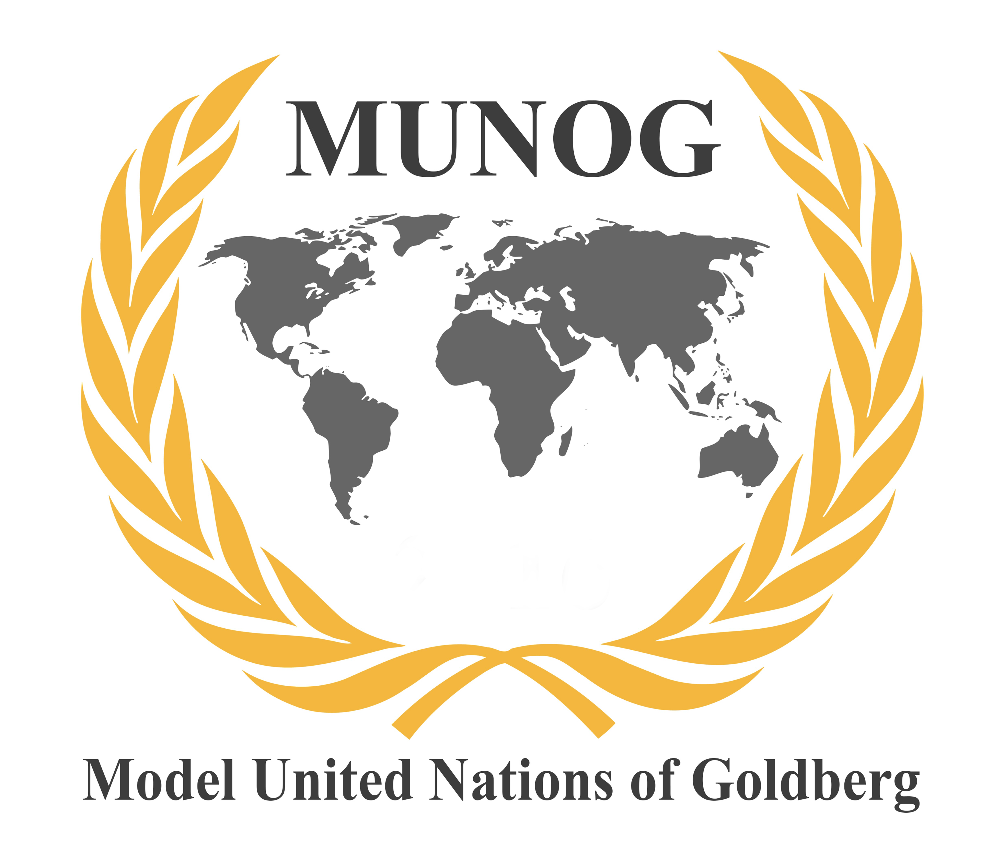
MUNOG 2026

Model United Nations of Goldberg 2026
Rules of Procedure

MUNOG 2026

Model United Nations of Goldberg
Sindelfingen, Germany

These are the Rules of Procedure of MUNOG 2026. The rules can only be amended by the MUNOG Office of the President of the General Assembly.
This is the final version.

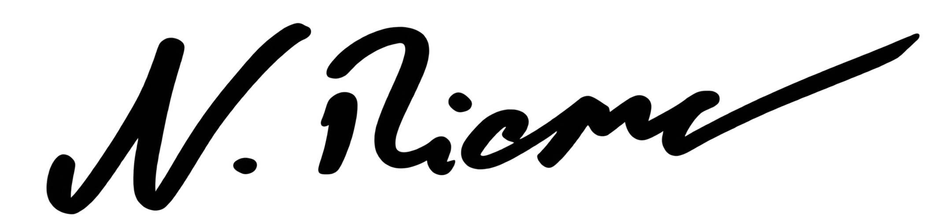
H. E.
Secretary-General

Table of Contents
Model United Nations of Goldberg 1
Table of Contents 2
Rules of Procedure 6
Preface 6
I. General Remarks 6
Art. 1 Decorum 6
Art. 2 Official and Working Language 7
Art. 3 Dress Code 7
Art. 4 Plagiarism 7
Art. 5 General Rules of Conduct 7
Art. 6 Misconduct 8
Art. 6.1 Punishments 8
Art. 7 Notepapers 8
Art. 8 Quorum 9
II. Presidency 9
Art. 9 The President 9
Art. 10 General Functions of the Presidency 10
Art. 11 Discretion of the President 10
III. The Secretary-General and the Secretariat 10
Art. 12 The Secretary-General 11
Art. 13 Conference Manager 11
Art. 14 Secretariat 11
IV. Conduct of Business 12
IV.1 Speeches, Floor and Approval Panel 12
Art. 15 Speeches 12
Art. 16 Floor 12
Art. 17 Approval Panel 13
IV.2 General Debate on the Agenda Item 13
Art. 18 General Debate on the Agenda Item 13
IV.3 Working Papers 13
Art. 19 Working Papers 13
(5) All Operative Clauses must begin with the following structures: 15
Accepts 15
Encourages 15
Recommends 15
Affirms 15
Endorses 15
Regrets 15
Approves 15
Expresses its appreciation 15
Requests (Security Council only) 15
Asks 15
Expresses its hope 15
Resolves 15
Authorizes (Security Council only) 15
Further invites 15
Seeks 15
Calls for 15
Further proclaims 15
Strongly affirms 15
Calls upon 15
Further recommends 15
Strongly condemns 15
Condemns (Security Council only) 15
Further requests 15
Strongly urges (Security Council only) 15
Confirms 15
Further resolves 15
Suggests 15
Congratulates 15
Hopes 15
Supports 15
Declares accordingly 15
Invites 15
Transmits 15
Deplores 15
Proclaims 15
Trusts 15
Decides (Security Council only) 15
Proposes 15
Urges (Security Council only) 15
Art. 20 Agenda 16
Art. 21 Submission of Working Papers 16
Art. 22 Introduction of a Draft Resolution 16
Art. 23 Formal Debate on a Draft Resolution and Voting Procedure 16
Art. 24 Amendments 17
Art. 25 Friendly and Unfriendly Amendments 18
Art. 26 Procedure on Draft Resolutions of Subsidiary Bodies in the General Assembly 18
IV.5 Points and Motions 19
IV.5.1 Points 19
Art. 27 General Procedure on Points 19
Art. 28 Point of Personal Privilege 19
Art. 29 Right of Reply 19
Art. 30 Point of Order 20
Art. 31 Point of Information 20
Art. 32 Point of Parliamentary Inquiry 20
IV.5.2 Motions 20
Art. 33 General Procedure on Motions 21
Art. 34 Appeal to the President’s Decision 21
Art. 35 Motion to Go into Q&A Session 21
Art. 36 Motion to Join the Speakers’ List 21
Art. 37 Motion to Suspend the Meeting for Informal Caucus (Lobbying) 22
Art. 38 Motion to Suspend Formal Debate for Moderated Caucus 22
Art. 39 Motion for P5 Caucus 22
Art. 40 Motion to Limit/Extend Speaking Time 22
Art. 41 Motion to Table Debate/Motion to Resume Debate 23
Art. 42 Motion to Close the General Debate 23
Art. 43 Motion to Move Directly into Voting Procedure on the Draft Resolution as a Whole 23
Art. 44 Motion to Vote by Roll Call 23
Art. 45 Motion to Explain the Vote 24
Art. 46 Motion to Divide the House 24
Art. 47 Motion to Exclude the Public 24
Art. 48 Motion to Invite a Guest Speaker 24
Art. 49 Order of Procedural Motions 24
IV.6 Voting 25
Art. 50 Substantial Voting 25
Art. 51 Procedural Voting 25
Art. 52 Conduct while in Voting Procedure 25
V. Course of Procedural Events 26
V.1 Opening Ceremony 26
Art. 53 Official Opening 26
Art. 54 Ambassador Speeches 26
V.2 General Assembly 26
Art. 55 Presentations of the Resolutions 26
Art. 56 Right to Express Declarations and Reservations 27
V.3 Closing Ceremony 27
Art. 57 Official Closing 27
VI. The Security Council 27
Art. 58 General 27
Art. 59 Primary Right of Consideration 28
Art. 60 Right of Invitation 28
Art. 61 Voting Procedures 28
Art. 62 Current Issue 28
VII. Closing Remarks 28
Art. 63 Amendments to Rules of Procedure 29

Rules of Procedure

Preface
These Rules of Procedure are based on the United Nations Charter and manifest the official orders that the Model United Nations of Goldberg (MUNOG) is to be conducted by. The main objective of these rules is to provide MUNOG with clearly devised rules of conduct, behavior and procedures.
They will apply to:
- The General Assembly (GA) with:
- The Security Council (SC),
- Disarmament and International Security Committee (DISEC),
- The Economic and Financial Committee (ECOFIN),
- The Human Rights Council (HRC),
- The World Health Organization (WHO),
- The Commission on the Status of Women (CSW),
- The Special Political and Decolonization Committee (SPECPOL),
- Committee on Peaceful Uses of Outer Space (COPUOS)
- United Nations High Commissioner for Refugees (UNHCR)
- United Nations Office on Drugs and Crime (UNODC)
- The Crisis Committee (CC)*,

I. General Remarks

Art. 1 Decorum
Delegates are to conduct themselves as diplomats at all times and always keep formal during the conference. They will be called to order by the Presidency if necessary.

Art. 2 Official and Working Language
English shall be the official and working language of the House during Formal Session and informal meetings.

Art. 3 Dress Code
(1) Participants are to be suitably dressed, wearing either:
long trousers and jacket/coat or trouser-suit or skirt and jacket/coat.
(2) The wearing of ties or bow ties is optional but strongly encouraged.
(3) Skirts must not be shorter than one palm above the knees.
(4) Attire that exposes the midriff and shoulders is not permitted
(5) Wearing traditional costume of the represented country is alternatively in order.
(6) Neither jeans nor sneakers are allowed.
(7) Non-compliance with the dress code may lead to a reprehension and is to be corrected for the further proceedings of the conference.

Art. 4 Plagiarism and Use of Artificial Intelligence (AI)
Proven plagiarism leads to the exclusion of the relevant document from the discussion. The Presidency will, in this case, make use of its power to declare a reprehension.
The Use of Artificial Intelligence is limited to the measures specified in the AI usage policy which is attached to this document.

Art. 5 General Rules of Conduct
(1) The Presidency and the members of a forum are to be addressed in third person singular only.
(2) Each Delegate refers to himself/herself in third person singular or first/third person plural only when speaking on behalf of his/her delegation.
(3) The Delegates always rise in order to speak and remain standing while speaking and receiving answers.
(4) There is no dialogue on the floor.
(5) Delegates must rise upon when the Secretary-General, the Deputy Secretary-General and the Presidents of the General Assembly enter their committee, but also when they appear at the Opening Ceremony and the General Assembly.

Art. 6 Misconduct
(1) The Presidency will warn Delegates if their conduct does not conform to these guidelines.
(2) If misconduct continues after this warning, the Presidency may take action, which might include the exclusion from the debate and conference.

Art. 6.1 Punishments
- Punishments shall be chosen by the Presidency and implemented by the Delegate if they misconduct these guidelines.
- Punishments must not involve discrimination or violation against the Delegate or the represented country.
- Before starting a punishment, the public must be excluded. Only members of the committee, the Secretary General, the Deputy Secretary General and the Presidents of the General Assembly may be present.
- For video recording and photos, the appropriate delegates must be asked for permission beforehand
Art. 7 Notepapers
(1) By raising a hand a Delegate signals to be in need of a notepaper or an amendment sheet and is provided with the necessary form by the administrative staff.
(2) The Presidency may at any point of time suspend notepaper passing and reserves the right to examine note papers at any time if deemed necessary.

Art. 8 Quorum
(1) A majority of the expected members (one half of the total plus one) of a committee shall be present for committee session to be opened. Regardless of quorum, the Presidency may open any meeting and commence with its proceedings at his discretion.
(2) A quorum is required to have a substantial vote, i.e. to vote on a resolution and/or amendment.

II. Presidency

Art. 9 The Presidency
(1) The term Presidency refers to the Presidents of the General Assembly and their representatives in committee, the Chairs.
(2) The Chairs of the committees of the General Assembly are thus representatives of the Presidents.
(3) The Presidency or the respective representative may make oral as well as written statements to any delegation concerning any issue.

Art. 10 General Functions of the Presidency
(1) The Presidency shall declare the opening and closing of each meeting.
(2) The Presidency, subject to these rules, shall have complete control of the proceedings at any meeting and shall moderate discussion, announce decisions, rule on points and motions and ensure the observance of these rules.
(3) The Presidency decides upon any doubtful or conflicting interpretation concerning these Rules of Procedure.
(4) The Presidency must, in any case, be able to explain in what manner her decision is in complete accordance with the fundamental principles of MUNOG. The Presidency will be at all times subject to these rules and responsible to the Secretary-General.
(5) For the clarification of a doubtful or conflicting interpretation, the Presidency may call upon the Secretary-General or the Presidents of the General Assembly for advice.
(6) The Presidency may declare reprehensions consequent to a Delegate’s non-compliance with Art. 1, 3 and 5. In case of a serious violation of these rules the exclusion may come into effect immediately. While excluded from the debate a Delegate may not participate in the voting procedures.

Art. 11 Discretion of the President
All procedural matters in Formal Session are subject to the discretion of the Presidency. The Presidency may undertake any action that is not covered in the Rules of Procedure in order to facilitate the flow of the debate.

III. The Secretary-General and the Secretariat

Art. 12 The Secretary-General
(1) The Secretary-General is the final and sole institution concerning any decision upon the interpretation of these rules. Final decisions have to be agreed by the Secretary-General and the Presidents of the General Assembly.
(2) In his performance of duties, the Secretary-General shall not seek or receive instructions from any person or from any other authority external to the organization.
(3) The Secretary-General may designate his Deputy to act on his behalf.
(4) The Secretary-General is to be addressed either with ’Your Excellency’, ’Most distinguished Mr. Secretary-General’ or ´Honorable Secretary-General´.
(5) The Secretary-General or his Deputy may take either oral or written statements to any forum at MUNOG concerning any question under consideration by it.
(6) His office is the Office of the Secretary-General. The official MUNOG delegate-service staff follows his instructions.

Art. 13 Executive Directors of the Conference Management
The Executive Directors of the Conference Management is the final and sole institution concerning any decision upon the organization of the MUNOG session. The official MUNOG staff follows her instructions.

Art. 14 Secretariat
(1) The Secretariat shall receive, print and distribute documents, working papers and draft resolutions of all MUNOG forums.
(2) It shall have the custody, proper preservation and distribution of all documents and credentials.
(3) The Secretariat shall generally perform all other work, which the forums may require.

IV. Conduct of Business

IV.1 Speeches, Floor and Approval Panel

Art. 15 Speeches
(1) Any Delegates wishing to speak shall raise their placards in order to indicate this to the Presidency. The order in which speakers are recognized is left to the discretion of the Presidency.
(2) The Presidency may, in the interest of the debate, or in order to work towards a consensus, call upon a particular delegation to speak, even if they have not requested the floor. The Presidency may also, for the same purposes, restrict the speaking time of an individual Delegate.
(3) All functions present should be addressed in respect to their titles (as: Secretary-General, Presidents, Delegates, NGOs, guests, etc.).
(4) All speeches must be related to the matter under discussion.
(5) Delegates refer to themselves in third person singular or first/third person plural only.
(6) Delegates have to yield the floor back to the Presidency when being requested to do so.

Art. 16 Floor
(1) No Delegate may address the body without the previously obtained permission of the Presidency.
(2) The Presidency may call a speaker to order if his or her remarks are not relevant to the subject under discussion.
(3) The speaking time is set by the Presidency. It can be limited or extended. The Presidency shall enforce the time limit.

Art. 17 Approval Panel
(1) The Approval Panel consists of MUN-Directors who scan the typed version of the working paper for formal correctness.
(2) Each working paper has to go through the Approval Panel and has to be marked as formally cleared before proceeding to the Presidency.

IV.2 General Debate on the Agenda Item

Art. 18 General Debate on the Agenda Item
(1) Before a committee moves into General Debate on an agenda topic time may be given to read out a position paper related to the agenda item.
(2) Speakers may speak on the agenda item being considered and may address any proposed working paper on the floor. Working papers may be proposed only when the committee is in general debate on the relevant topic.
(3) In their speeches on an agenda topic Delegates have the opportunity to express their countries’ opinions and their concerns as well as to suggest solutions. This also applies to NGOs.

IV.3 Working Papers

Art. 19 Working Papers
(1) A working paper is a written form of a country’s opinion about one item under discussion that shows the format of a resolution.
(2) It is to be prepared by each Delegate prior to the opening of the official conference. Working papers shall be introduced in writing.
(3) A working paper consists of a heading (name and title of the committee/council, agenda item, main submitter, co-submitters), preambulatory Clauses and operative clauses.
(4) All Preambulatory Clauses must begin with one of the following structures:

Acknowledging | Emphasizing | Keeping in mind
Affirming | Expecting | Noting further
Alarmed by | Expressing its appreciation | Noting with appreciation
Approving | Expressing its satisfaction | Noting with approval
Aware of | Fulfilling | Noting with deep concern
Bearing in mind | Fully alarmed | Noting with regret
Believing | Fully aware | Noting with satisfaction
Confident | Fully believing | Observing
Congratulating | Further deploring | Pointing out
Contemplating | Further recalling | Reaffirming
Convinced | Guided by | Realizing
Declaring | Having adopted | Recalling
Deeply concerned | Having considered | Recognizing
Deeply conscious | Having considered further | Referring
Deeply convinced | Having devoted attention | Taking into account
Deeply disturbed | Having examined | Taking into consideration
Deeply regretting | Having heard | Taking note
Deploring | Having received | Viewing with appreciation
Desiring | Having studied | Welcoming

(5) All Operative Clauses must begin with the following structures:
Accepts | Encourages | Recommends
Affirms | Endorses | Regrets
Approves | Expresses its appreciation | Requests (Security Council only)
Asks | Expresses its hope | Resolves
Authorizes (Security Council only) | Further invites | Seeks
Calls for | Further proclaims | Strongly affirms
Calls upon | Further recommends | Strongly condemns (Security Council only)
Condemns (Security Council only) | Further requests (Security Council only) | Strongly urges (Security Council only)
Confirms | Further resolves | Suggests
Congratulates | Hopes | Supports
Decides (Security Council only) | Invites | Transmits
Declares accordingly | Proclaims | Trusts
Deplores | Proposes | Urges (Security Council only)

Art. 20 Agenda
The House shall deal with the agenda topics in the order determined in the first committee session. The time allowed for the debate of each agenda topic shall likewise be determined in the first session.

IV.4 Rules Governing Formal Debate on Draft Resolutions

Art. 21 Submission of Working Papers
(1) Working papers shall be submitted to the Presidency typed.
(2) In order to be submitted, working papers shall require the signature of at least 10% of the Quorum. One delegation cannot sign more than one working paper per agenda item.
(3) The three working papers with the most co-submitters, which have been handed in by the end of general debate, are admitted into debate by the Presidency. In the event of a tie, the Presidency will decide to enter informal caucus again, by which the committee may force a decision on its own.

Art. 22 Introduction of a Draft Resolution
(1) A draft resolution is an approved working paper that is introduced in the committee.
(2) Following the agreement to introduce the draft resolutions with the most co-submitters first, the operative clauses are read out loud by the respective main submitter and afterwards elaborated in a speech.
(3) In the following, the floor is open for formal debate on the draft resolutions.

Art. 23 Formal Debate on a Draft Resolution and Voting Procedure
(1) Every formal debate on a draft resolution commences in general debate.
(2) After general debate the operative clauses of the draft resolution will be discussed separately. Following the debate on each operative clause, the corresponding amendments will be discussed.
(3) Amendments which stipulate the introduction of new operative clauses will be dealt with subsequently. Amendments may be submitted to newly added operative clauses. They will be discussed immediately after the operative clauses have been added.
(4) Afterwards, amendments, which change the order, will be discussed.
(5) After the debate on the finished draft resolution the committee is to vote on the draft resolution as a whole.
(6) If the draft resolution fails to reach a majority, the debate on the next draft resolution is to be commenced. If there are no further draft resolutions the agenda item is closed.
(7) As soon as a resolution has been passed, the agenda item is closed. Reopening a closed agenda item is not possible.
(8) If the last remaining draft resolution is withdrawn, the committee may resume general debate on the agenda item at the discretion of the presidency.

Art. 24 Amendments
(1) An amendment is a proposal that adds to, deletes from, or revises part of a draft resolution. Furthermore, the order of the operative clauses can be changed. Only operative clauses can be amended – amendments to preambulatory clauses are not in order.
(2) Amendments shall be submitted to the Presidency in written form.
(3) If there are several amendments to a specific operative clause, the committee shall first vote on the amendment diverging the most from the original proposal, then on the amendment diverging the second most, and so on, until all amendments have been put to the vote. According to this procedure, the order will be laid down at the discretion of the President.
(4) As soon as an amendment is debated upon, the submitter state will be given the opportunity by the Presidency to present and explain its proposal in a speech.
(5) Following the speech, there will be general debate on the amendment.
(6) Once debate on the amendment is closed, the committee will move to an immediate vote.

Art. 25 Friendly and Unfriendly Amendments
(1) Friendly amendments are changes that are immanently non-substantive matters, e.g. grammar and spelling mistakes. Such an amendment is automatically included in the draft resolution and does not need to be voted upon if all the submitters of the draft resolution agree to the amendment.
(2) An amendment to an amendment can only be friendly.
(3) Once the presidency declares the amendment for unfriendly, the Delegate proposing the amendment is asked to introduce their reason for the proposal.
(4) Afterwards the committee/council/organization moves on to the voting procedure. An unfriendly amendment is being adopted to the draft resolution when having gained a simple majority.

Art. 26 Procedure on Draft Resolutions of Subsidiary Bodies in the General Assembly
This Procedure shall apply to all Subsidiary Bodies of the General Assembly and the Main Committees (DISEC, SPECPOL, ECOFIN):
(1) A subsidiary body decides upon the order of the draft resolutions to be introduced to the supreme body by vote.
(2) Following the introduction of the draft resolution by the main-submitter trough a speech. The main submitter may yield the floor with the remaining time to one of his co-submitters if he wishes to.
(3) In the following, the floor is open for each one speech against and in favour of the discussed resolution.
(4) After the debate on the draft resolution the committee is to vote on the draft resolution as a whole. Voting clause by clause is not in order.
(5) If the draft resolution fails to reach a majority the next subsidiary body introduces its first draft resolution.
(6) A draft resolution becomes a resolution if it passes in the General Assembly.

IV.5 Points and Motions

IV.5.1 Points

Art. 27 General Procedure on Points
(1) If not stated otherwise, points may not interrupt a speaker.
(2) It is up to the Presidency if a point is entertained. Improper points may be overruled.
(3) Delegates raising a point should remain standing until the matter has been dealt with.
(4) Points are not put to a vote.

Art. 28 Point of Personal Privilege
(1) During the discussion of any matter, a Delegate may raise a Point of Personal Privilege. The President shall immediately address the point.
(2) A point of personal Privilege may interrupt a speaker in an urgent matter and must refer to a matter of personal comfort, safety, well-being of the members of the House or subject to audibility.

Art. 29 Right of Reply
The Presidency shall recognize the Right of Reply only in instances of a grave personal insult. The Delegates must state which remark he/she considered to be an offense and then answer to it diplomatically. The Right of Reply may only be entertained after a speech, not after POIs or Q&A Sessions.

Art. 30 Point of Order
(1) Points of Order must relate to the observance of the rules of the House or to the way the Presidency is exercising its power.
(2) A Delegate raising a Point of Order may not speak on the substance of the matter under discussion.

Art. 31 Point of Information
(1) After a Delegate has given a speech, Points of Information can be raised by Delegates from the floor.
(2) The Presidency grants Points of Information only after asking the speaker whether he/she accepts these points. Points of Information are directed to the speaker and allow other delegations to ask questions in relation to speeches, amendments and draft resolutions.
(3) Points of Information must be phrased as questions. Delegates should remain standing until the Point of Information has been answered.
(4) One follow-up question is to be phrased as question and is in order if requested by the Delegate and accepted by the chair.

Art. 32 Point of Parliamentary Inquiry
A delegate may raise a Point of Parliamentary Inquiry to request clarification on all procedural matters in general from the Presidency.
Informal language is in order.

IV.5.2 Motions

Art. 33 General Procedure on Motions
(1) If not stated otherwise, motions may not interrupt a speaker.
(2) In general, a simple majority is required.
(3) If not stated otherwise an objection to a motion is possible, the Delegate who has brought forward the motion and the one who has objected may shortly explain their reasons.
(4) If a motion has been seconded at least twice and not objected, it is automatically accepted unless the Presidency decides not to entertain the motion.
(5) If there is an objection the motion needs to be voted on.
(6) Points of Information are not in order. There will be no debate.

Art. 34 Appeal to the President’s Decision
(1) An appeal is raised when a Delegate feels that the Presidency has made an incorrect ruling.
(2) The appeal shall immediately be put to a vote.
(3) A two-thirds majority is required.

Art. 35 Motion to Go into Q&A Session
(1) A Q&A session allows they Delegates to pose questions to a single Delegate. The Delegate to be questioned must be named and must agree to the proposal.
(2) If the motion passes, the Presidency will moderate the questioning.
(3) Delegates may join the Q&A session by raising a motion to do so.

Art. 36 Motion to Join the Speakers’ List
(1) Motion to Join the Speakers’ List shall be used when a Delegate wishes to be added to the Speakers’ List. This Motion is up to the discretion of the Presidency.

Art. 37 Motion to Suspend the Meeting for Informal Caucus (Lobbying)
(1) Upon the motion of any Delegate, the House may consider a Motion to Suspend the Meeting for the purpose of informal caucus (lobbying).
(2) The motion must specify the purpose and the duration of the proposed suspension.
(3) During informal caucus Delegates may leave the committee.
(4) After informal caucus the committee work shall start with a roll call.
(5) A simple majority is required.

Art. 38 Motion to Suspend Formal Debate for Moderated Caucus
(1) The purpose of suspending formal debate for moderated caucus is to have a less formal debate moderated by the Presidency in order to clarify countries’ positions.
(2) The motion must propose the duration of the proposed suspension.
(3) A two-thirds majority is required.

Art. 39 Motion for P5 Caucus
(1) This Motion shall be applied only in the Security Council in case a permanent member is intending to vote against (veto) an Operative Clause or Draft Resolution as a whole.
(2) With the contribution of the Presidency the P5 members should gather in a separate area and discuss the controversial point.
(3) The entertainment of this motion is subject to the discretion of the Presidency.

Art. 40 Motion to Limit/Extend Speaking Time
The Delegate must propose speaking time.

Art. 41 Motion to Table Debate/Motion to Resume Debate
(1) During the discussion of any matter, the House may consider a Motion to Table Debate on the item under discussion at the recommendation of the Presidency or any Delegate.
(2) If a Motion to Table Debate is passed, the topic is considered tabled and no further actions or votes will be taken on it.
(3) A topic may be reintroduced to the House so that debate can resume through the same process.
(4) A two-thirds majority is required.

Art. 42 Motion to Close the General Debate
(1) The acceptance of the motion entails the progression to the next stage.
(2) A two-thirds majority is required

Art. 43 Motion to Move Directly into Voting Procedure on the Draft Resolution as a Whole
(1) A two-thirds majority is required.
(2) The Presidency may overrule the motion.

Art. 44 Motion to Vote by Roll Call
(1) A roll call vote may be requested on draft resolutions. This motion is automatically approved and does not require a vote unless the Presidency decides not to entertain it.
(2) The roll call vote shall be taken in alphabetical order of the English names of the member states present. During a roll call vote, delegations may answer with an affirmative vote, a negative vote, an abstention.
(3) Voting by roll call is mandatory for the vote on the resolution as a whole.

Art. 45 Motion to Explain the Vote
(1) The Delegate who raised this Motion can require any Delegates to explain their vote.
(2) The Delegates subject to this Motion shall give proper clarification of their vote.

Art. 46 Motion to Divide the House
When voting on amendments Delegates show their placards and answer with ‘in favour’ or ‘against’. Abstentions are not in order.

Art. 47 Motion to Exclude the Public
(1) A Motion to Exclude the Public may be raised if the Presidency or the Delegates feel disturbed by the public or want to continue committee work with complete confidentiality.
(2) The motion must specify the purpose and the duration of the proposed exclusion.
(3) A two-thirds majority is required.
(4) This Motion does not apply to the Secretary General, Deputy Secretary General and the Presidents of the General Assembly.

Art. 48 Motion to Invite a Guest Speaker
(1) A guest speaker can be invited from another committee to give a speech concerning one of the agenda items, especially if the topic is related to a country which is not represented in the committee.
(2) The motion must explain the purpose.
(3) Chairs inform each other via notepapers and grant the speaker time for preparation.

Art. 49 Order of Procedural Motions
The points and motions shall have precedence as listed above.

IV.6 Voting

Art. 50 Substantial Voting
(1) Substantial Voting is related to decisions on substantial matters, i.e. draft resolutions and amendments.
(2) Observer States and nongovernmental organizations (NGOs) are not allowed to vote on substantial matters.
(3) Each Delegate present shall have one vote.
(4) The House shall vote by show of placards while answering with ‘in favour’, ‘against’ or ‘abstention’.
(5) A simple majority is required.

Art. 51 Procedural Voting
(1) Procedural Voting is related to any decisions that are not related to substantial matters.
(2) NGOs and Observer States are allowed to vote.
(3) Delegations physically present may not abstain on procedural voting.
(3) In general, procedural decisions shall be made by a simple majority of the quorum.

Art. 52 Conduct while in Voting Procedure
(1) After the Presidency has announced the beginning of voting, no representative may enter or leave the room, nor shall any representative interrupt the voting except on a Point of Personal Privilege, Point of Parliamentary Inquiry, or a Point of Order in connection with actual conduct of the voting.
(2) Delegates will be silent and will not pass notepapers.
(3) A roll call vote shall be taken in the alphabetical order of the member states present. During a roll call vote, delegations may answer with an affirmative vote, a negative vote, or abstention. Voting by role call is not a necessary, only when voting on the Resolution as a whole

V. Course of Procedural Events

V.1 Opening Ceremony

Art. 53 Official Opening
The Secretary-General declares the session as open.

Art. 54 Ambassador Speeches
(1) Ambassador Speeches are delivered after the official opening of the conference. They allow the ambassador out of five specified delegations to set forth their country’s position concerning the items on the agenda. Ambassador speeches are limited to two minutes.
(2) After every opening speech, up to three points of information will be entertained by the Presidency. They must clearly refer to the respective speech. Points of NGOs are in order.

V.2 General Assembly

Art. 55 Presentations of the Resolutions
(1) The Chairs of the respective committee will take upon the role of experts during the General Assembly. The resolutions are only shown at the front but not read out. Only the resolution of the Main Committee DISEC is read out by the Main Submitter. The Main Submitter gives a speech in favour of the resolution. There will then be 2 minutes of lobbying time to prepare questions and speeches. Afterwards there are two speeches in favour and two speeches against the resolution, limited to a Maximum of one and a half minutes.
(2) After the General Assembly has discussed and voted on the draft resolutions of its subsidiary bodies (according to Art. 26), the resolutions of the other councils and committees will be presented by the respective council and committees as directed by the chairs.
(3) During the General Assembly Delegates shall not leave the room. In exceptional cases e.g., risk to personal health Delegates may raise a Point of Personal Privilege.

Art. 56 Right to Express Declarations and Reservations
Any member state may express their dissenting opinion on the resolutions in a written declaration or reservation, which might be appended to the Goldberg Declaration.

V.3 Closing Ceremony

Art. 57 Official Closing
The Secretary-General officially declares the conference as closed.

VI. The Security Council

Art. 58 General
Rules mentioned in this section are special to the Security Council and thus to be primarily considered by it.

Art. 59 Primary Right of Consideration
While the Security Council is discussing any dispute or situation assigned to it, no other forum shall make any recommendation with regard to that dispute or situation unless the Security Council so requests.

Art. 60 Right of Invitation
The Delegate of any member nation of MUNOG, which is not a member of the Security Council, if it is a party to a dispute under consideration by the Security Council, may be invited to participate, without vote, in the discussion relating to the dispute.

Art. 61 Voting Procedures
(1) Each member of the Security Council shall have one vote.
(2) Decisions of the Security Council on procedural matters shall be made by an affirmative vote of nine members.
(3) Decisions of the Security Council on all other matters shall be made by an affirmative vote of nine members, including the concurring votes of the permanent members; however, a permanent member may abstain from voting without preventing the adoption of a decision.
(4) The Delegates are to be silent. There will be no notepaper passing.

Art. 62 Current Issue
The Secretary-General shall immediately bring to the attention of all representatives on the Security Council all communications from states, organs of the United Nations, or the Secretary-General concerning any matter for the consideration of the Security Council in accordance with the provisions of the Charter.

VII. The Crisis Committee

Art. 63 General

Rules mentioned in this section are special to the Crisis
Committee and thus to be primarily considered by it.

Art. 64 The CC

The exact way of operating and all specialties of the CC are noted down
in the “Booklet for CC Delegates”.

VIII. Closing Remarks

Art. 63 Amendments to Rules of Procedure
These rules of procedure may only be amended by a decision of the MUNOG 2026 Office of the Secretary-General.

